MSL Recruitment Portal — Functional Requirement
Document Version: 1.0
Date: 25/11/2025
Audience: MSL Admin, MSL Clients, Job Seekers
The portal defines three main user roles:
Role | Description | Key Permissions
MSL Admin | Manages the platform, users, and content. | - Create/disable user accounts  - Moderate job postings and profiles  - Manage system settings and view reports
MSL Client | Corporate representatives hiring talent. | - Create and manage company profile  - Post, edit, and archive job listings (Request)  - Search and view job seeker profiles  - Manage received applications
Job Seeker | Individuals looking for employment opportunities. | - Create and edit a public/profile  - Upload resumes and portfolios  - Search and apply for jobs  - Manage application tracker

Purpose: This manual explains how to use the MSL Recruitment Portal (LinkedIn-like interface). It includes step-by-step workflows, UI screenshots placeholders (for proofing), roles & permissions, common tasks, troubleshooting, and a short technical overview (HTML/CSS/JS stack).
Item | Description
Audience | MSL Admin, MSL Clients, Job Seekers
Purpose | This manual provides a complete guide to using the MSL Recruitment Portal, designed with a LinkedIn-style interface. It covers user workflows, feature navigation, UI layout references (with screenshot placeholders), user roles and permissions, standard operational tasks, troubleshooting procedures, and a concise technical overview.
Hosting Environment | Hosted on Microsoft IIS (Internet Information Services) web server to ensure high performance, secure access, and stable deployment.
Database | Oracle Database is used as the primary data management system, offering reliability, scalability, and robust transaction handling for recruitment data, job postings, and user profiles.
Technology Stack | Built using HTML, CSS, and JavaScript for the front-end. The system architecture supports future integration of modern frameworks such as React or Vue.js to enhance user interactivity and performance.
lSystem Architecture | Implements a Three-Tier Architecture: Presentation Layer (Web UI), Application Logic (Server-side scripts), and Database Layer (Oracle DB). This structure ensures modularity, maintainability, and scalability.
Version Control | Managed through Git for collaborative development, change tracking, and maintaining codebase integrity across multiple contributors.
Security | All user credentials are securely hashed and encrypted. HTTPS protocol is enforced for all communications, and the system uses Role-Based Access Control (RBAC) for user privileges (Admin, Client, Job Seeker).
Email & Notification Services | The system integrates an SMTP-based email service for sending verification emails, OTPs (One-Time Passwords), and notifications. This service requires an additional allocated budget for SMTP hosting, email quotas, and domain authentication (SPF/DKIM) to ensure secure delivery and reliability.
Budget Consideration | An additional SMTP service cost is included in the deployment budget to cover OTP verifications and automated system notifications, ensuring smooth user onboarding and secure login verification.

Table of contents
Contents
MSL Recruitment Portal — Functional Requirement 1
Table of contents 3
1. Executive Summary & Project Vision 4
2. Introduction & Key Concepts 6
3. System Context & Scope 7
System Context Diagram 7
4. Roles & Permissions (Quick matrix) 9
5. Job Seeker Guide 11
5.1 Registration 11
5.2 Login 21
5.3 Dashboard & Top Job Picks 23
5.4 Search & Apply for Jobs 23
5.5 Profile Update 24
5.6 Document Upload & Replace 25
5.7 Notifications & Activity 27
5.8 Profile 28
I. Core Access Control Logic 29
6. MSL Client Guide 31
6.1 Login 31
6.2 Current Jobs — Overview & Management 31
What Client’s See When Client Log In 31
Client Job Requests List 32
How It Works - Simple Steps 32
6.3 Post New Job (Request post job form) 36
6.4 Alerts & Notifications 39
6.5 Invoice Management (View & Print) 45
6.6 Agreements Management 49
7. MSL Admin Guide 53
MSL Administrators maintain the highest system privileges with comprehensive access to platform management and monitoring capabilities. 53
7.1 Admin Dashboard Overview 53
7.2 Seekers Management 54
7.3 Clients Management 57
7.4 Current Posted Jobs 59
7.5 Job Invoices & Resume Access 62
7.6 Interview Schedule Management 65
7.7 Logs & Audit Trail 70
8. Accessibility, Security & Data Privacy Notes 73
9. Non-Functional Requirements (NFRs) 74
10. Technical Overview (HTML / CSS / JS only) 74
11. Executive Summary & Project Vision 75
12. Data Dictionary / Entity Relationships 75
13. API Specification (Placeholder) 76
14. Comprehensive Use Cases / User Stories 76
15. Wireframes or Mockups Reference 77
SEEKER 77
CLIENT 81
ADMIN 84
16. Gantt Chart 86
17. Deployment & Infrastructure Guide 88
18. Test Strategy & Plan 88
19. Appendix 88

Executive Summary & Project Vision
The MSL Recruitment Portal represents a strategic digital transformation initiative designed to revolutionize talent acquisition within the medical science liaison ecosystem. This modern, LinkedIn-style platform connects high-caliber MSL professionals with leading healthcare organizations through an intuitive, secure, and efficient digital marketplace.
Built on a robust three-tier architecture and hosted on Microsoft IIS with Oracle Database, the platform ensures enterprise-grade performance and reliability. The system incorporates secure SMTP-based communication services for seamless user verification and engagement, supported by dedicated budget allocation to ensure deliverability and security.

Operational Excellence
- Automate Administrative Tasks: Reduce manual administrative overhead by 40% through automated notifications, status tracking, and reporting
- Improve User Engagement: Achieve 85% user satisfaction scores across all user roles through intuitive design and responsive functionality
- Ensure Platform Reliability: Maintain 99.5% system uptime with scalable architecture supporting future growth

Success Metrics (KPIs)
Adoption & Engagement Metrics
- User Registration Targets: 1,000+ active job seekers and 50+ corporate clients within first 6 months
- Platform Activity: Minimum 70% monthly active user rate across all user segments
- Job Application Rate: Average of 15+ qualified applications per job posting
- Purpose: To provide a high-level overview for stakeholders, managers, and new team members.
- Content:
  - Project Vision Statement: A single, inspiring sentence. E.g., "To create the most efficient and user-friendly recruitment platform for the medical science liaison (MSL) field."
  - Business Objectives: List the key goals. E.g., "Reduce time-to-hire by 30%," "Improve candidate quality through better matching," "Centralize client and candidate management."
  - Success Metrics (KPIs): How will success be measured? E.g., User registrations per month, job application rate, client satisfaction score, reduction in administrative overhead.
  - Target Audience Recap: Briefly summarize the three user roles and their primary value from the system.

System Performance Metrics
- Email Delivery Success: Maintain 98%+ successful delivery rate for OTP and notification emails
- User Satisfaction Scores: Target 4.5/5.0 average rating in quarterly user surveys
- System Uptime: Maintain 99.5% availability with sub-2-second page load times

2. Introduction & Key Concepts
The MSL Recruitment Portal is a streamlined, responsive web platform designed with an intuitive LinkedIn-style user experience. The system architecture supports three distinct user roles, each with specialized workflows and interface elements tailored to their recruitment needs.
User Roles & Core Functionality
Job Seeker
- Create and maintain dynamic professional profiles
- Upload and manage CVs and supporting documents
- Browse and apply to relevant job opportunities
- Receive personalized job recommendations through intelligent matching
MSL Client
- Post and manage job listings with detailed requirements
- Track and evaluate candidate applications through dedicated pipelines
- Access invoice tracking and agreement management systems
- Schedule and coordinate interviews through integrated calendaring
MSL Admin
- Oversee platform moderation and user management
- Manage job postings, applications, and billing operations
- Maintain system integrity and data quality
- Generate comprehensive recruitment analytics and reports
User Interface Design Framework
Visual Design Patterns
- Cards & Feeds: Primary layout components for job listings, candidate profiles, and notification streams
- Top Job Picks: Personalized recommendation engine utilizing profile analysis, search history, and application patterns
- Action-Oriented Interface: Prominent primary action buttons (Apply, Post Job, Schedule Interview) driving user workflows
- Modal Interactions: Lightweight overlay forms for quick actions including application confirmation and document uploads

3. System Context & Scope
- Purpose: This section defines the operational boundaries of the MSL Recruitment Portal and outlines its interactions with external systems and services, providing clarity on system capabilities and limitations for stakeholders and technical teams.

System Context Diagram
Core System & User Interactions
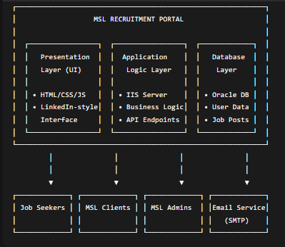
External System Integrations
Primary External Dependencies:
- Email Service (SMTP): Dedicated SMTP service for user verification (OTP), system notifications, and communication alerts
- Oracle Database: Primary data storage for user profiles, job postings, applications, and system configuration
- Authentication Service: Future-ready architecture supporting potential Google Authentication integration
- Web Server Infrastructure: Microsoft IIS hosting environment for application deployment and management
Scope Definition
In-Scope Features
Core Platform Functionality:
- User registration, authentication, and profile management for all three roles
- Job posting, searching, and application management workflows
- Personalized job recommendations using keyword and behavioral matching
- Document upload and management (CVs, resumes, supporting documents)
- Email notification system for OTP verification and system alerts
- Basic interview scheduling and calendar management
- Invoice tracking and agreement management for client users
- Administrative moderation and user management capabilities
Technical Infrastructure:
- Three-tier architecture implementation (Presentation, Application, Database)
- Role-Based Access Control (RBAC) security model
- Responsive web interface with LinkedIn-style UX patterns
- SMTP-integrated email communication services
- Oracle Database integration for data persistence
Out-of-Scope Features
Excluded from Current Release:
- Real-time chat/messaging system between clients and job seekers
- Advanced analytics and business intelligence dashboards with predictive modeling
- Native mobile applications for iOS or Android platforms
- Video interviewing integration with third-party platforms (Zoom, Teams, etc.)
- Automated resume parsing and data extraction technologies
- Social media integration for profile importing or sharing
- Multi-language and internationalization support
- Advanced reporting with custom export capabilities
- API endpoints for third-party system integration
- Bulk email marketing or newsletter functionality
Future Enhancement Considerations:
- Integration with external HRIS systems
- Advanced candidate matching algorithms using machine learning
- Mobile application development
- Extended payment gateway integration for premium services
- Advanced reporting and analytics modules
Assumptions & Constraints
Technical Assumptions:
- All users have reliable internet access and modern web browsers
- SMTP service remains operational for critical system communications
- Oracle Database maintains required performance levels for concurrent users
- Microsoft IIS environment provides stable hosting infrastructure
Business Constraints:
- Budget allocation for SMTP services covers expected email volume
- User adoption follows projected growth patterns
- Administrative resources available for platform moderation and support

4. Roles & Permissions (Quick matrix)

Feature / Action | Job Seeker | MSL Client | MSL Admin
Authentication
Login | ✅ | ✅ | ✅
Email Verification (OTP) | ✅ | ✅ | ✅
Job Management
View Jobs | ✅ | - | ✅
Search & Filter Jobs | ✅ | - | ✅
Apply to Job | ✅ | — | ✅ (as emulator)
Post Job | — | ✅ (as request) | ✅
Edit Job Posts | — | ✅ (own only) | ✅
Application Workflow
Manage Applications | — | ✅(own only) | ✅
Track Application Status | ✅ | — | —
Schedule Interviews | — | ✅(own only) | ✅
Financial & Legal
View Invoices | — | ✅(own only) | ✅
Manage Agreements | — | ✅(own only) | ✅
User Management
Blacklist Seeker | — | — | ✅
Suspend Client | — | — | ✅
Moderate Content | — | — | ✅
Profile Management
Create/Edit Profile | ✅ | ✅ | ✅
Upload Documents | ✅ | ✅ | ✅
Notifications
Receive Job Alerts | ✅ | — | —
System Notifications | ✅ | ✅ | ✅

Permissions are role-based and can be extended via admin settings.

5. Job Seeker Guide

5.1 Registration
The registration form collects essential candidate data through structured input fields:
Field Name | Data Type | Max Length | Input Type | Description / Validation
first_name* | VARCHAR | 100 | Text | Legal first name for identity verification
last_name* | VARCHAR | 100 | Text | Legal surname for official records
full_name with int* | VARCHAR | 150 | Text | Auto-generated complete name display
email* | VARCHAR | 150 | Email | Primary account identifier and communication channel
phone_number* | VARCHAR | 15 | Tel | International format contact number with country code
alternate_phone | VARCHAR | 15 | Tel | Secondary contact number (optional backup)
preferred_contact_method* | VARCHAR | 50 | Dropdown | Communication priority: Email / Phone / LinkedIn
linkedin_url* | VARCHAR | 255 | URL | Professional profile validation and networking
current_address* | VARCHAR | 255 | Textarea | Current residential location for geographic matching
nationality* | VARCHAR | 100 | Dropdown | Citizenship information for compliance and filtering
work_authorization_status* | VARCHAR | 100 | Dropdown | Visa and work eligibility status for employment compliance
*Mandatory field - Must be completed for registration submission

Current Position
Field Name | Data Type | Max Length | Input Type | Description / Validation
current_company* | VARCHAR | 150 | Text | Current employer organization name
current_title* | VARCHAR | 100 | Text | Official job title and position level
industry* | VARCHAR | 100 | Dropdown | Sector classification for industry matching
company_size | VARCHAR | 50 | Dropdown | Organizational scale for context (1-10, 11-50, 51-200, etc.)
start_date* | DATE | — | Date Picker | Employment commencement date for experience calculation
current_total_compensation* | DECIMAL(12,2) | — | Number | Annual compensation package in local currency
key_responsibilities* | TEXT | — | Textarea | Core job functions and daily operational duties
team_size_management* | INT | — | Number | Direct reports count for leadership scope assessment
budget_responsibility | DECIMAL(12,2) | — | Number | Financial oversight amount for responsibility level

Career Objective
Field Name | Data Type | Max Length | Input Type | Description / Validation
career_goals_aspirations | TEXT | — | Textarea | Long-term professional vision and target career trajectory
target_role_type* | VARCHAR | 100 | Dropdown | Employment preference: Full-time, Contract, Part-time, Executive
target_industries | VARCHAR | 255 | Multi-select Dropdown | Industry sectors of interest for job matching
preferred_company_size | VARCHAR | 50 | Dropdown | Ideal organization scale: Startup, SME, Enterprise, Large Corp
preferred_company_stage | VARCHAR | 50 | Dropdown | Company development phase: Early-stage, Growth, Established, Mature

Experience and Skills
Field Name | Data Type | Max Length | Input Type | Description / Validation
total_years_experience* | INT | — | Number | Cumulative professional work history in years
years_in_executive_roles* | INT | — | Number | Leadership tenure for executive position matching
core_competencies* | VARCHAR | 255 | Multi-select Dropdown / Tag Input | Primary professional skills for keyword-based job matching
industry_experience* | VARCHAR | 255 | Multi-select Dropdown | Previous industry sectors worked in for relevance scoring
functional_experience* | VARCHAR | 255 | Multi-select Dropdown | Professional domains and specialized functional areas
languages* | VARCHAR | 255 | Multi-select Dropdown | Language proficiencies for localization and role requirements

Previous Experiences and Skills (Candidate Summary):
- Professional Experience: The candidate has a total of X years of professional experience, including Y years in executive or leadership roles.
- Core Competencies: Skilled in [list key skills, e.g., PHP, React, SQL, Flutter], with demonstrated ability in [specific tasks/projects].
- Industry Exposure: Worked in industries such as [list industries, e.g., IT, Financial Services, Delivery].
- Functional Experience: Experienced in roles/functions like [e.g., Web Development, Software Engineering, Client Management].
- Languages: Proficient in [list languages].

Education
Field Name | Data Type | Max Length | Input Type | Description / Usage
highest_degree* | VARCHAR | 100 | Dropdown | Highest academic qualification (Bachelor, Master, etc.).
field_of_study* | VARCHAR | 150 | Text | Main academic specialization (e.g., Computer Science).
University* | VARCHAR | 150 | Text | Name of institution.
graduation_year* | YEAR | — | Dropdown / Year Picker | Year of graduation.
additional_certifications* | VARCHAR | 255 | Text / Tag Input | Additional qualifications or short courses.

Feature: Certificate Uploader
Description:
The system will allow users to upload educational and professional certificates. Uploaded documents will be stored securely and linked to the user’s profile for verification and reference purposes.
Functional Requirements:
- Upload Functionality:
  - Users can upload certificates in supported formats (PDF, JPG, PNG).
  - Maximum file size: 10 MB.
  - Option to add a certificate title, issuing organization, and issue date.
- Validation & Security:
  - System validates file type and size before uploading.
  - Uploaded documents are scanned for viruses and malicious content.
  - Access to uploaded certificates is restricted based on user roles.
- Storage & Retrieval:
  - Certificates are stored securely in the system’s document repository.
  - Users can view, download, or delete their own certificates.
  - Admin/stakeholders can verify and approve certificates if required.
- Audit & Tracking:
  - All uploads, edits, and deletions are logged for audit purposes.
  - Notifications sent to stakeholders for newly uploaded documents requiring verification.
Location and Mobility
Field Name | Data Type | Max Length | Input Type | Description / Usage
preferred_work_location* | VARCHAR | 150 | Dropdown / Text | Location(s) preferred for work.
willingness_to_relocate* | BOOLEAN | — | Checkbox | Willing to move for a job.
travel_willingness* | VARCHAR | 50 | Dropdown (None / Occasionally / Frequently) | Comfort level for travel requirements.
remote_work_preferences* | VARCHAR | 100 | Dropdown | Hybrid, Fully Remote, or On-site preference.

Compensation Expectation
Field Name | Data Type | Max Length | Input Type | Description / Usage
target_base_salary_min rename as expected take home salary(input) * | DECIMAL(12,2) | — | Number  Range | Minimum expected base salary.
target_base_salary_max  rename as gross salary * | DECIMAL(12,2) | — | Number  Range | Maximum expected base salary.
Additional allows | VARCHAR(255) | — | Multi selection checkboxes | Optional selection of additional benefits/allowances requested (e.g., bonus, health insurance, transport).
target_total_compensation | DECIMAL(12,2) | — | Number | Full package expectation (salary + bonuses).
importance_of_equity | VARCHAR | 50 | Dropdown (Low / Medium / High) | Priority for stock/equity options.
additional_compensation_notes | TEXT | — | Textarea | Extra details like bonuses or perks.

Privacy and Consent (Seeker Guide)
Confidentiality and Disclosure
Field Name | Data Type | Max Length | Input Type | Description / Usage
confidentiality_level | VARCHAR | 50 | Dropdown (Basic / Standard / Strict) | Level of visibility allowed on profile.
reference_check_permission* (after selection | BOOLEAN | — | Checkbox | Permission for recruiters to verify references.

Availability
Field Name | Data Type | Max Length | Input Type | Description / Usage
current_employment_status* | VARCHAR | 50 | Dropdown (Employed / Unemployed / Freelance / Student / Other) | Indicates the seeker’s current work status. Used to determine activity level and availability.
search_status* | VARCHAR | 100 | Dropdown (Actively Looking / Open to Offers / Not Looking / Confidential Search) | Describes how actively the candidate is searching for a new job. Used for recruiter visibility and job matching filters.
notice_period* | VARCHAR | 50 | Dropdown (Immediate / 1 Week / 2 Weeks / 1 Month / 2 Months / Other) | Specifies the notice period the candidate must serve before joining a new company.
earliest_available_start_date | DATE | — | Date Picker | The earliest date the candidate is available to start a new position. Helps match urgent openings.
availability_notes | TEXT | — | Textarea | Additional notes about the candidate’s schedule, commitments, or flexibility (e.g., “Available after project handover in Nov”).

Additional Information
Field Name | Data Type | Max Length | Input Type | Description / Usage
additional_information | TEXT | — | Textarea | Any other relevant notes from the candidate.
how_hear_about_us | VARCHAR | 100 | Dropdown / Text | Source of referral (LinkedIn, Website, Friend, etc.).
special_requests | TEXT | — | Textarea | Specific requests or accessibility needs.

Submission
Field Name | Data Type | Max Length | Input Type | Description / Usage
submission_date | DATETIME | — | Auto | System-generated timestamp.
digital_signature | VARCHAR | 255 | Text / Auto | Candidate’s e-signature or name confirmation.

5.2 Login
Path: Home → Sign In → "Job Seeker" tab
Fields: Email / Username, Password. Optional: Sign in with Google.
Field Name | Data Type | Max Length | Input Type | Description / Usage
user_id | VARCHAR | 100 | Text | Unique user identification ID used for authentication and profile mapping. Can be system-generated or chosen by the user. Must be unique across the platform.
password | VARCHAR | 255 | Password (Encrypted) | Secure password used for login verification. Stored in encrypted (hashed) form using a strong algorithm like bcrypt or Argon2.

Password Policy
To ensure secure authentication, all passwords must meet the following requirements:
Rule | Requirement
Minimum Length | 8 characters
Uppercase Letters | At least 1 uppercase letter (A–Z)
Lowercase Letters | At least 1 lowercase letter (a–z)
Numbers | At least 1 numeric character (0–9)
Symbols | At least 1 special character (e.g., @, #, $, %, !, *, ?, &)
No Spaces | Password cannot contain blank spaces
Encryption | Stored using bcrypt or Argon2 hashing algorithm for maximum security

Email Validation Rules
Rule | Requirement
Format | Must follow standard email format (username@domain.com)
Uniqueness | Email must be unique across the system (cannot be reused)
Case Handling | Emails are stored in lowercase for consistency
Verification | Confirmation link is sent to validate email ownership before full access

Optional Authentication Feature
Feature | Description
Sign in with Google | Uses Google Multifactor for single-click sign-in. If it’s a new user, the system auto-creates a verified seeker account using their Google profile details.

Flow:
- Enter credentials & click Sign In.
- Multifactor enabled, enter the code sent via SMS/Email.
- Upon success you land on the Seeker Dashboard.
Errors:
- Invalid credentials → show message: "Email or password incorrect. Forgot password?"
- Account suspended → show support contact.
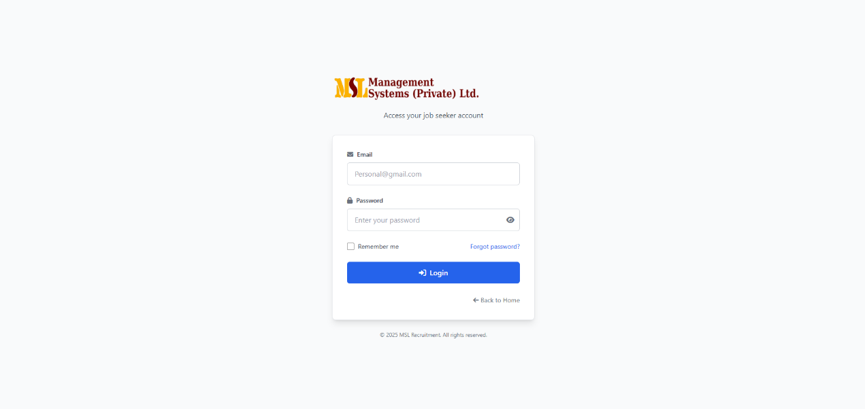

5.3 Dashboard & Top Job Picks
What you'll see:
- Welcome card with quick links (Profile, Documents, Applied Jobs)
- Top Job Picks — a horizontally scrollable list of recommended jobs.
- Recent activity (applies, saved jobs, messages)
How Top Job Picks are chosen (simple explanation for users):
- Matches between your profile skills, location, and job keywords.
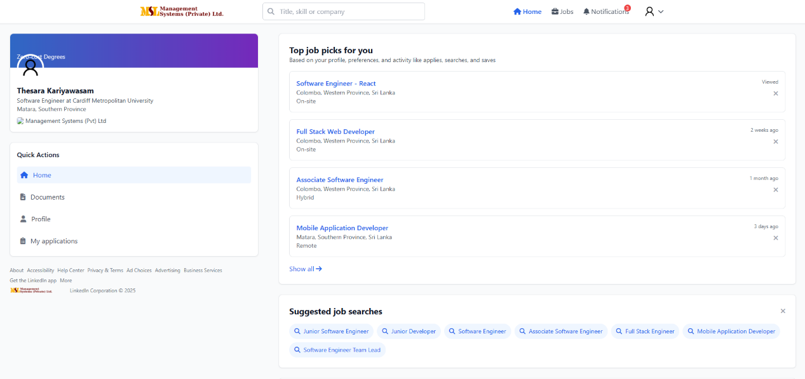
- Your activity (applies, searches, saves) influences rankings.

5.4 Search & Apply for Jobs
Search: Use top search bar — filters: Keyword, Location, Job Type, Sector, Experience level, Salary range.

Apply flow:
- Click job card → open Job Details panel.
- Click Apply → confirm CV/document and add a short message (optional).
- Click Submit Application.
- Confirmation toast and the job move to Applied Jobs.
Notes:
- You can re-open your application to check status.
- If CV access is restricted by the client, the admin or client will unlock it after approval.

5.5 Profile Update
Path: Dashboard → Profile → Edit
Key fields: Full name, Professional headline, Location, Contact details, Experience, Education, Skills, Visibility (Public / Private).
Tips:
- Fill skills as comma-separated tags.
- Keep headline short and specific (e.g., "Clinical Science Liaison — 5 yrs").
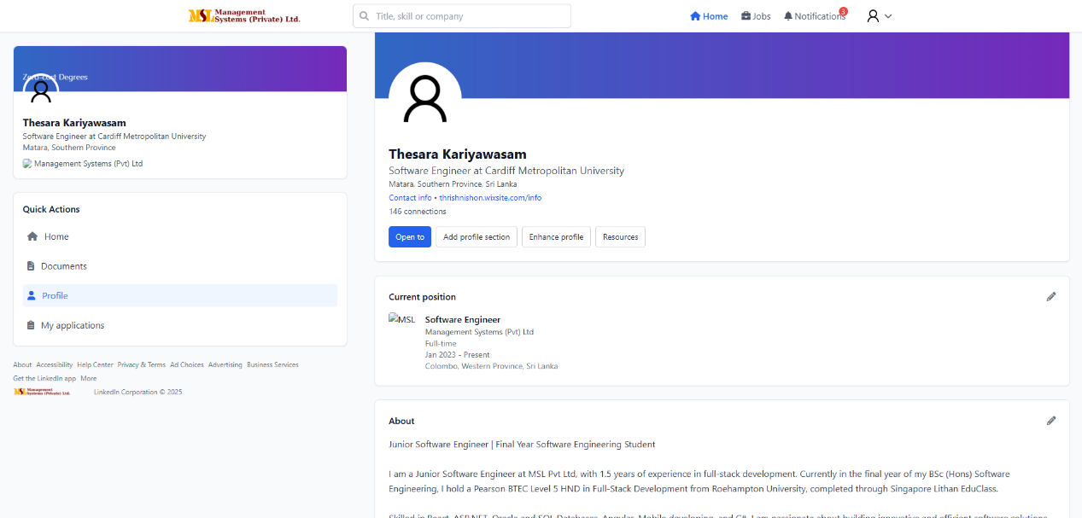
Saving: Click Save. Changes reflect in recommendations within a few minutes (client-side re-index).

5.6 Document Upload & Replace
Path: Profile → Documents
This section allows seekers to upload, store, and manage their professional and identification documents. Users can choose which documents are visible to recruiters or keep them private.
Field Name | Data Type | Max Length | Input Type | Description / Usage
document_id | INT | — | Auto Increment | Unique ID for each uploaded document.
seeker_id | INT | — | Foreign Key | Links the document to the respective seeker’s profile.
document_type | VARCHAR | 100 | Dropdown (Birth Certificate / NIC / Driving License / Cover Letter / Service Letters / Resume / Other) | Type of uploaded document. Used for filtering and labeling.
document_name | VARCHAR | 150 | Text | File name or title as uploaded by the user.
document_file | VARCHAR | 255 | File Upload | File path or URL of the uploaded document (stored in the server or cloud).
upload_date | DATETIME | — | Auto | Timestamp of when the document was uploaded.
visibility_status | BOOLEAN | — | Toggle / Checkbox | Determines if the document is visible to recruiters (TRUE = Visible, FALSE = Hidden).
description | TEXT | — | Textarea (Optional) | Short note about the document (e.g., “Updated resume with recent project details”).

Allowed file types: PDF, DOCX, JPG/PNG (for ID). Max 5 MB per file.
Upload flow:
- Click Upload → choose file → select document type (CV, Cover Letter, Certification, ID).
- Click Upload → success alert.

Supported Document Types
Document Type | Description | Accepted File Formats
Birth Certificate | Used for identity verification and nationality proof. | PDF, JPG, PNG
NIC (National ID Card) | Legal identity proof for citizens. | PDF, JPG, PNG
Driving License | Secondary ID or verification of mobility eligibility. | PDF, JPG, PNG
Cover Letter | Personalized introduction for job applications. | PDF, DOCX
Service Letters | Proof of previous employment or experience. | PDF, JPG
Resume / CV | Main professional document summarizing qualifications. | PDF, DOCX

Replace flow:
- Locate the document in the list → click Replace.
- Upload new file → click Confirm Replace.
Functional Features
Feature | Description
Upload Document | Seeker can upload multiple documents under specific categories.
Visibility Control | Each document includes a visibility toggle to manage recruiter access.
Edit / Replace | Seekers can update or replace existing documents anytime.
Preview & Download | Uploaded files can be previewed or downloaded for personal use.
Storage | Documents are stored securely in the system or cloud (e.g., oracle db).

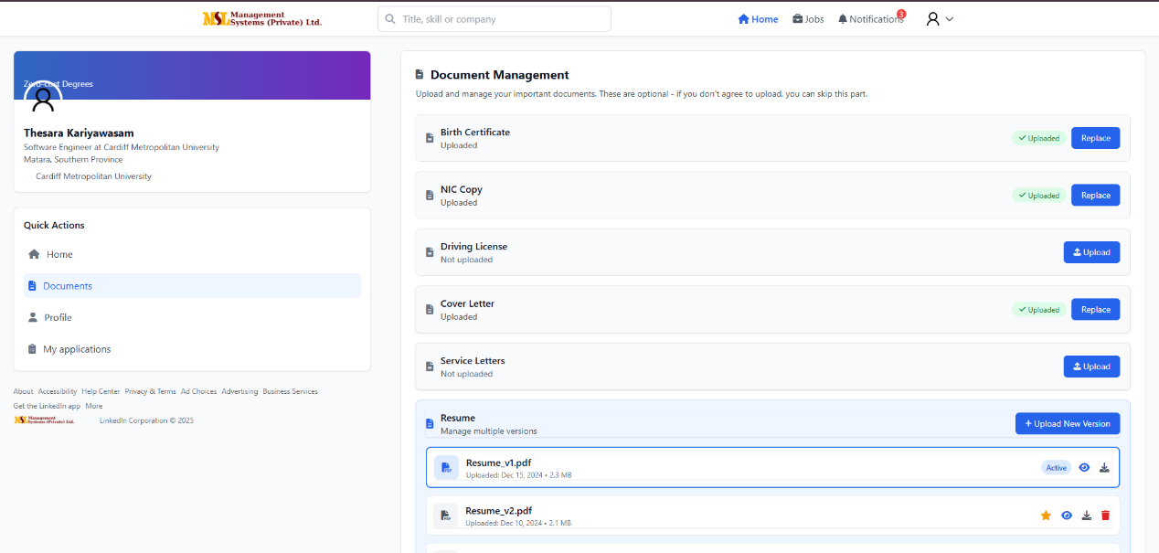
Versioning: Previous versions are kept for 30 days (admin settings), with Latest indicated.

5.7 Notifications & Activity
Common notifications: Application Received, Interview Scheduled, Application Rejected, Message from Client.
Settings: Dashboard → Settings → Notifications (Email / In-app / SMS optional).

5.8 Profile
The Job Seeker Profile module acts as the central hub for all candidate-related information collected during registration. It displays and manages personal details, professional experience, documents, and multiple resume versions.
Each seeker’s profile serves as their public-facing identity within the system, visible to recruiters according to privacy and visibility settings.
Main Contents Displayed
The seeker’s profile dynamically displays information retrieved from the registration module, including:
- Personal Information – Name, Contact Details, Nationality, LinkedIn, etc.
- Career Profile – Objectives, Aspirations, Target Roles, and Preferred Industries.
- Experience and Skills – Years of Experience, Core Competencies, Functional Areas, and Languages.
- Education – Degrees, Universities, Certifications.
- Location and Mobility – Preferred Work Locations, Relocation, and Travel Preferences.
- Compensation Expectations – Expected salary range and total package expectations.
- Availability – Current employment status, notice period, and earliest start date.
- Documentation Management – Uploaded files such as NIC, Birth Certificate, Service Letters, and Resume.
- Resume Version Control – Manage multiple resume versions (detailed below).

Resume Version Control
Feature | Description
Version History | The system allows each seeker to upload and manage up to three (3) resume versions. Each version may reflect a different role focus (e.g., Technical Resume, Management Resume, or General Resume).
Version Metadata | Each resume includes metadata such as version name, upload date, description, and visibility status.
Version Management | Seekers can add, update, replace, or delete resume versions at any time.
Active Resume Selection | One version can be marked as “Active” to be shown to recruiters by default.
Version Preview | Allows the seeker to preview or download the resume before sharing.
Storage and Access | Each resume is securely stored and versioned by system ID for retrieval and comparison.

Core Access Control Logic
1. User Creation & Authentication
- Each individual user is created as a unique client by MSL Admin
- Credentials are user-specific: Username + Password (e.g., Thesara|Heylies|Password123)
- Password reset capability provided
- No company-wide logins - each user has separate access
2. Job-Based Permission Framework
- Job Reference Number is the primary permission controller
- Each job is permanently linked to the specific user who created it
- Job visibility and management rights are scoped exclusively to:
  - The individual client user who created the job
  - The specific MSL Admin assigned to handle that job
3. Data Isolation Examples
Scenario 1: Same Company, Different Users
Company: Heylies
User Thesara → Creates Job001 → Visible only to Thesara + MSLADMIN1
User Piyasiri → Creates Job002 → Visible only to Piyasiri + MSLADMIN2
Thesara CANNOT see Job002, Piyasiri CANNOT see Job001

Scenario 2: MSL Admin Assignment
Job001 → Assigned to MSLADMIN1
Job002 → Assigned to MSLADMIN2
MSLADMIN1 can manage Job001 (resumes, invoices, agreements)
MSLADMIN1 CANNOT access Job002 unless explicitly assigned
Revised Workflow Summary
Client Side:
- Individual user receives unique credentials from MSL Admin
- User logs in and can only create new job requests
- Each job gets auto-generated unique Job Reference Number
- User can only view/manage jobs they personally created
- No visibility into other users' jobs, even from same company
MSL Admin Side:
- Admin creates individual user accounts (not company accounts)
- When job request is approved, specific MSL Admin is assigned
- Admin can only manage jobs assigned to them
- All job data (resumes, invoices, agreements) is accessible only to the assigned admin
- Comprehensive audit trail through Job Reference Number tracking

6. MSL Client Guide

6.1 Login
Path: Home → Sign In → "MSL Client" tab
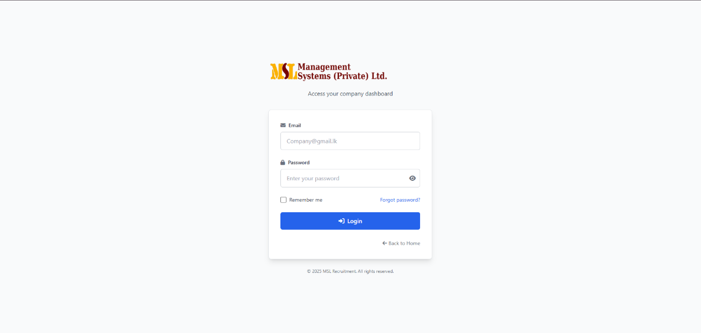
Fields: Company email, password, optional SSO.

Field Name | Data Type | Max Length | Input Type | Description / Usage
email | VARCHAR | 150 | Email | Registered email used for authentication and password recovery.
password | VARCHAR | 255 | Password (Encrypted) | Securely stored hashed password used for login verification.

6.2 Current Jobs — Overview & Management

What Client’s See When Client Log In
When you log in, you'll see four quick numbers that show your hiring progress:
- Waiting for Approval: Jobs you've asked to post that are being reviewed
- Live Jobs: Your jobs that are approved and visible to candidates
- New Applications: People who have applied to your jobs and need your review
- Interviews Planned: Meetings scheduled with candidates

Client Job Requests List
Below the numbers, you'll see all the jobs you've asked to post:
For each job request, you can see:
- Job Name - The position title
- Request Number - Your unique tracking code
- Date Sent - When you submitted the request
- How Many Applied - Only shows for approved jobs
- Job Category - Type of work (IT, Sales, etc.)
- Current Status:
  - Being Reviewed - We're looking at your request
  - Approved - Job is live and candidates can apply
  - Not Approved - We couldn't post it (we'll tell you why)
- Our Notes - Any messages from our team
- What You Can Do - Options like "See Applicants" or "Ask for Changes"

How It Works - Simple Steps
Getting a Job Posted:
- You Ask - Fill out the job form and send it to us
- We Check - Our team reviews your request
- We Decide - We either approve (job goes live) or say no (with reasons)
After Job is Approved:
- See Applicants - View people who applied to your job
- Plan Interviews - Set up meetings with candidates
- Watch Progress - See how candidates move through hiring steps
- Ask for Changes - Request updates to job details through us
- Close Job - Ask us to remove the job when filled
Important Things to Know
- We Approve All Jobs - You request, we review and post
- Only See Your Jobs - You can't see jobs from other people, even in your same company
- Limited Editing - Ask us if you need to change job details
- Only Your Applicants - You only see people who applied to your jobs
- Everything Goes Through Us - We handle the system side
We'll Keep Client Updated
- Job Status Alerts - We tell you when your job request status changes
- New Applicant Alerts - We notify you when someone applies
- Messages from Our Team - We can send you notes and updates
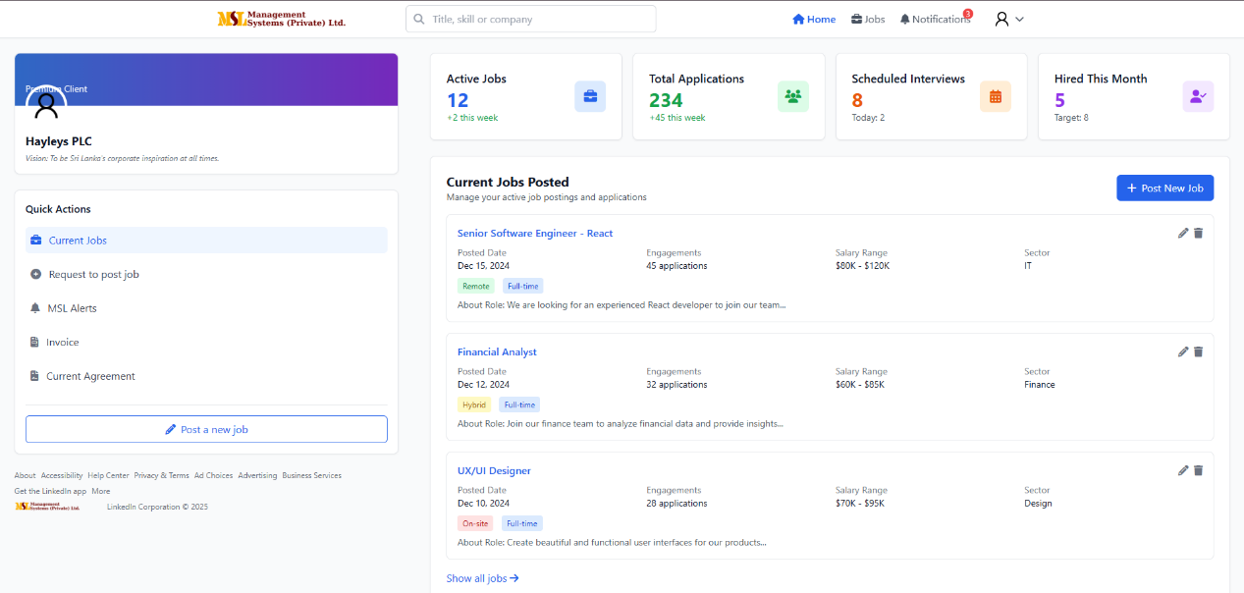
- System News - We tell you about any platform changes

Client Dashboard - Quick Overview
Client Dashboard Numbers
When client log in, they’ll see these four important numbers about their hiring:
Number Shown | What It Means | How We Calculate It
Active Jobs | How many of clientuser jobs are currently open and accepting applications | Counts only clientuser approved jobs that are live on the site
Total Applications | How many people have applied to all client active jobs | Adds up all applications across clientuser active jobs
Scheduled Interviews | How many interviews clientuser have planned for this month | Shows upcoming interviews for clientuser jobs only
Hired This Month | How many people clientuser've hired this month | Counts hires from clientusers jobs in current month
Last Updated | When these numbers were last refreshed | Shows today's date automatically
How We Track client Jobs
Important: Each job clintuser create gets a unique Job ID number. This Job ID is like a tracking number that follows clientuser job through the entire process.
What the Job ID does:
- Links the job specifically to clientuser (no one else can see it)
- Tracks all applications, interviews, and hires for that job
- Helps our team manage clientuser job efficiently
- Ensures clientuser only see information for clientuser own jobs
Client Personal Job List
Below the numbers, you'll see all the jobs you've asked us to post. For each job, you can see:
- Client Job ID - The unique tracking number for your job
- Job Title - The position name
- Date Submitted - When you sent it to us
- Applications - How many people applied (only shows for approved jobs)
- Job Type - What kind of work it is
- Status - Where your job is in the process
- Our Notes - Messages from our team
- Actions - What you can do with this job
Simple Rules
- Clientuser only see your own jobs - not jobs from other people in clientuser company
- Each job has its own unique Job ID
- All clientusers job information is private to clientuser
- Our team can help with any job using the Job ID
B. Current Jobs Listing Table
Job Tracking Fields
Field Name | Data Type | Max Length | Input Type | Description / Usage
job_id | INT | — | Auto-Generated (Primary Key) | Unique tracking number for each job post that controls all permissions
position | VARCHAR | 150 | Text | Job title or designation (e.g., "Senior React Developer")
posted_date | DATETIME | — | Auto-Generated | Date and time when the job was published by admin
engagements_count | INT | — | Auto-Calculated | Total number of candidate interactions (views, clicks, applications)
salary_range | VARCHAR | 50 | Text | Displayed salary bracket (e.g., "LKR 100,000 - 150,000")
sector | VARCHAR | 100 | Dropdown | Industry or business sector (e.g., "Technology", "Healthcare")
status | VARCHAR | 20 | System Controlled | Current job status: "Under Review", "Active", "Closed", or "Rejected"
about_role | TEXT | — | Text Area | Brief description of role purpose and key responsibilities
client_user_id | INT | — | Foreign Key | Links job to the specific client user who created it

Key System Rules
- Job ID is Primary Control: Each job receives a unique Job ID that determines:
  - Which client user can view and manage the job
  - Which MSL admin is assigned to handle the job
  - What permissions are granted for resumes, invoices, and agreements
- Strict Data Isolation: Jobs are only visible to:
  - The specific client user who created the job request
  - The assigned MSL admin responsible for that job
- Status-Driven Workflow: Job status controls available actions and visibility throughout the recruitment process

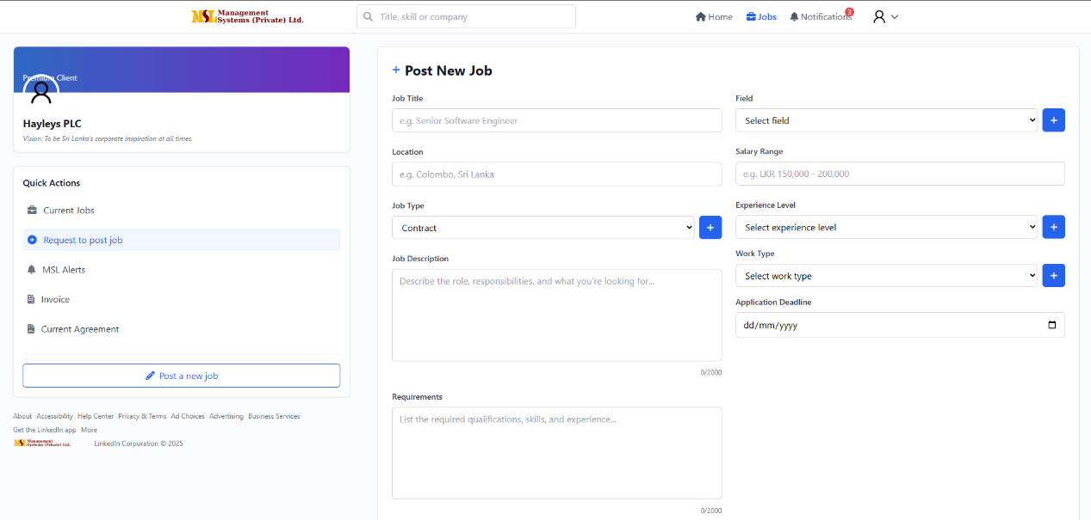
6.3 Post New Job (Request post job form)

Field Name | Data Type | Max Length | Input Type | Description / Usage
job_id | INT | — | Auto-Generated (Primary Key) | Unique job tracking number that controls all permissions and access
job_title | VARCHAR | 150 | Text | Official title of the job position (e.g., "Software Engineer")
field | VARCHAR | 100 | Dropdown | Job category/industry selection (IT, Marketing, Finance, etc.)
location | VARCHAR | 120 | Text | Geographical location (city, region) or remote work specification
salary_range | VARCHAR | 50 | Text | Offered salary range for the position
job_type | VARCHAR | 50 | Dropdown | Employment type (Full-Time, Part-Time, Contract, etc.)
experience_level | VARCHAR | 50 | Dropdown | Required experience level (Entry, Mid, Senior, etc.)
job_description | TEXT | — | Text Area | Detailed duties, responsibilities, and role expectations
work_type | VARCHAR | 50 | Dropdown | Work arrangement (On-site, Remote, Hybrid)
application_deadline | DATE | — | Date Picker | Final date for applicant submissions
requirements | TEXT | — | Text Area | Essential qualifications, skills, and certifications needed
status | VARCHAR | 20 | System-Generated | Initial status: "Pending Approval" until admin review
posted_date | DATETIME | — | Auto-Generated | Date and time when job request was submitted
client_user_id | INT | — | System-Generated | Links job to specific client user who created the request

Job Request Workflow
Submission Process:
- Client user completes required job information form
- System automatically generates unique Job ID
- Job request status is set to "Pending Approval"
- Request is submitted to MSL Admin for review
- Client user receives confirmation of submission
Post-Submission:
- Job request appears in client user's "My Job Requests" with Pending status
- Assigned MSL Admin reviews and approves/rejects the request
- Only upon admin approval does job become active on portal
- Job ID becomes the access control key for all job-related data
Access Control Rules
- Job ID Based Permissions: The auto-generated Job ID determines which client user and MSL admin can access the job data
- Individual User Isolation: Each job is permanently linked to the specific client user who created the request
- Admin Assignment: Upon approval, specific MSL admin is assigned to manage the job using the Job ID
- Strict Data Segregation: No other client users, even from same company, can view or access the job

6.4 Alerts & Notifications
Notification Settings
- Configuration: Settings → Notifications (Email & In-app options)
- Daily Digest: Client users can enable summary email notifications
- Real-time Alerts: Immediate notifications for critical events
Interview Scheduled Notifications
Field Name | Data Type | Max Length | Input Type | Description / Usage
alert_id | INT | — | Auto-Generated (Primary Key) | Unique identifier for each interview alert
job_id | INT | — | System-Generated | Links alert to specific job for access control
client_user_id | INT | — | System-Generated | Identifies which client user receives this alert
alert_time | DATETIME | — | Auto-Generated | System timestamp when alert was created
position | VARCHAR | 150 | Text | Job position title for the scheduled interview
location | VARCHAR | 120 | Text | Interview location (address or virtual meeting link)
date | DATE | — | Date Picker | Scheduled interview date
time | TIME | — | Time Picker | Interview start time
interview_type | VARCHAR | 50 | Dropdown | Interview format: Online, Virtual, In-person, Phone
candidate_name | VARCHAR | 120 | Text | Full name of candidate attending interview
experience_years | DECIMAL(3,1) | — | Numeric | Candidate's total years of professional experience
skills | VARCHAR | 255 | Text | Key skills or technologies candidate is proficient in
recommendation_status | VARCHAR | 50 | Dropdown | Internal recruiter assessment: Recommended, Not Recommended, Pending
status | VARCHAR | 30 | System-Generated | Alert progress: Upcoming, Completed, Cancelled
Notification Types & Examples
Common Alert Categories:
- Interview Scheduled - New interview arranged for candidate
- Candidate Confirmed - Candidate accepted interview invitation
- Scheduled for Today - Reminder for interviews happening today
- Application Received - New candidate applied to job
- Status Change - Job request approved/rejected by admin
Access Control & Data Isolation
- Job ID Based Filtering: Notifications are filtered by Job ID to ensure client users only see alerts for their own jobs
- User-Specific Delivery: Each notification is linked to specific client_user_id for targeted delivery
- Permission Enforcement: Alert visibility follows the same Job ID permission rules as other system features
- Admin Assignment: MSL admins only receive notifications for jobs assigned to them
Notification Workflow
- System event triggers alert creation
- Alert is linked to specific Job ID and client user
- Notification is delivered based on user's preferred method (email/in-app)
- Alert status updates automatically based on interview progress
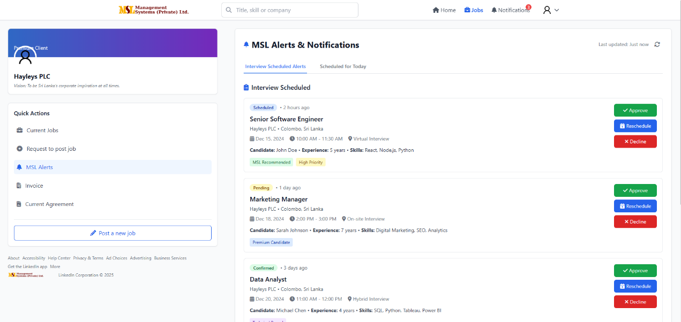
- Client user can manage notification preferences in Settings

Other Notifications Tab
Field Name | Data Type | Max Length | Input Type | Description / Usage
notification_id | INT | — | Auto-Generated | Unique identifier for each general notification
job_id | INT | — | System-Generated | Links notification to specific job for access control (Primary Key)
client_user_id | INT | — | System-Generated | Identifies which client user receives this notification
get_time | DATETIME | — | Auto-Generated | System timestamp when notification was generated
title | VARCHAR | 150 | Text | Notification title or subject line
description | TEXT | — | Text Area | Detailed message content of the notification
notification_type | VARCHAR | 50 | Dropdown | Category: System, Reminder, Update, Info, Status Change
read_status | BOOLEAN | — | Checkbox | Indicates if notification has been viewed by client user
Notification Categories & Examples
System Notifications:
- Job request status updates (Approved/Rejected)
- System maintenance alerts
- Password change confirmations
Reminder Notifications:
- Application deadline approaching
- Pending interview feedback requests
- Unread message reminders
Update Notifications:
- Job modification requests processed
- Profile update confirmations
- Settings change notifications
Information Notifications:
- New platform features
- Policy updates
- Training availability announcements
Access Control & Delivery Rules
- Job-Based Filtering: Notifications are scoped to specific Job IDs ensuring client users only receive relevant alerts
- User-Specific Targeting: Each notification is delivered based on client_user_id matching
- Permission Inheritance: Follows the same Job ID access control as other system modules
- Status Tracking: Read status allows users to manage notification visibility and prioritize unread messages

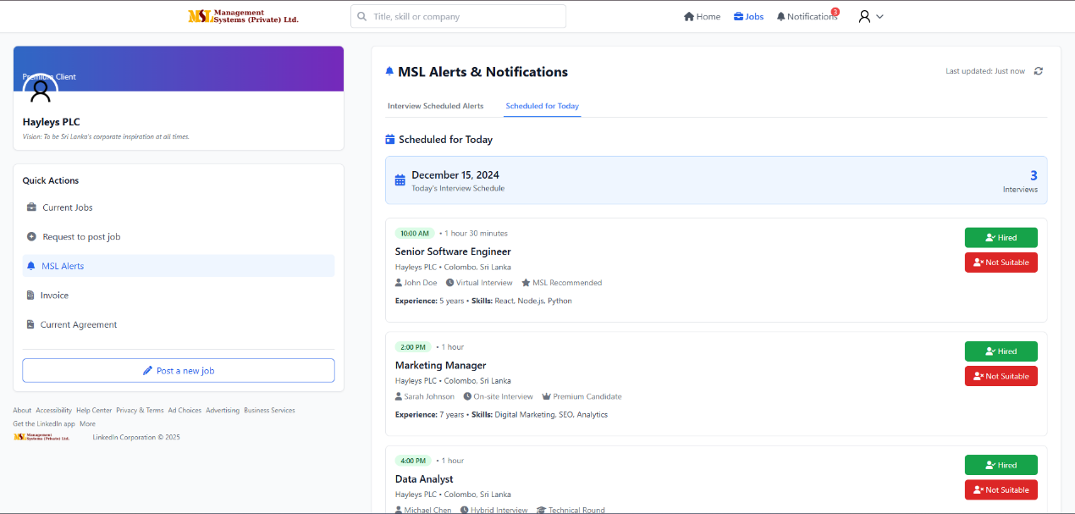
Scheduled for Today Tab

Field Name | Data Type | Max Length | Input Type | Description / Usage
schedule_id | INT | — | Auto-Generated | Unique identifier for daily scheduled interviews
job_id | INT | — | System-Generated | Primary key linking schedule to specific job for access control
client_user_id | INT | — | System-Generated | Identifies which client user owns this interview schedule
current_date | DATE | — | System-Generated | Displays current system date for filtered daily view
interview_count | INT | — | Auto-Calculated | Number of interviews scheduled for the specific day
time | TIME | — | Time Picker | Scheduled interview time slot
experience | DECIMAL(3,1) | — | Numeric | Candidate's total professional experience in years
position | VARCHAR | 150 | Text | Job title associated with the scheduled interview
recommendation | VARCHAR | 50 | Dropdown | Recruiter assessment: Recommended, Not Recommended, Pending
location | VARCHAR | 120 | Text | Physical location or virtual meeting link for interview
skills | VARCHAR | 255 | Text | Key skills and technologies relevant to the position
candidate_name | VARCHAR | 120 | Text | Full name of the scheduled candidate
interview_type | VARCHAR | 50 | Dropdown | Interview format: Online, Virtual, In-person, Phone
Access Control & Data Filtering
- Job-Based Scope: Schedule data is filtered by Job ID to ensure client users only see interviews for their own jobs
- User-Specific View: Each client user's daily schedule displays only interviews linked to their assigned Job IDs
- Permission Inheritance: Follows same Job ID access control rules as other system modules
- Real-time Updates: Schedule automatically updates based on interview bookings and cancellations
Daily Schedule Features
- Date-Focused View: Organized by current system date for easy daily planning
- Time Slot Management: Clear chronological display of interview times
- Candidate Insights: Quick access to candidate experience, skills, and recommendations
- Interview Logistics: Location and format details for proper preparation
- Count Tracking: Automated tally of daily interview load for workload management

6.5 Invoice Management (View & Print)
Location: Dashboard → Billing → Invoices
Invoice Summary Overview
Field Name | Data Type | Max Length | Input Type / Source | Description / Usage
job_id | INT | — | System-Generated | Primary key linking invoices to specific job for access control
client_user_id | INT | — | System-Generated | Identifies which client user owns these invoice records
total_invoices | INT | — | Auto-Calculated | Total number of invoices generated for the client user
pending_payments | INT | — | Auto-Calculated | Number of unpaid or pending invoices for the client user
total_spends | DECIMAL(10,2) | — | Auto-Calculated | Total amount spent by the client user across all their jobs
Invoice Management Interface
Invoice List View:
- Displays list of invoices filtered by Job ID and client user
- Shows invoice status: Pending, Paid, Overdue
- Each invoice linked to specific Job ID for access control
Invoice Details:
- Clicking an invoice opens detailed view
- Details include: Invoice number, date, amount, services, due date
- Print functionality available for each invoice
Access Control & Data Isolation
- Job-Based Billing: Each invoice is linked to specific Job ID ensuring client users only see invoices for their own jobs
- User-Specific Financial Data: Invoice summaries calculate totals based only on jobs belonging to the specific client user
- Permission Enforcement: Follows same Job ID access control rules as other system modules
- Financial Segregation: Client users cannot view invoices from other users, even within same company
Invoice Workflow
- Invoice Generation: Automatically created based on job activities and services
- Status Tracking: Real-time updates of payment status (Pending, Paid, Overdue)
- User Access: Client users can only access invoices linked to their Job IDs
- Reporting: Financial summaries calculated per client user across their job portfolio

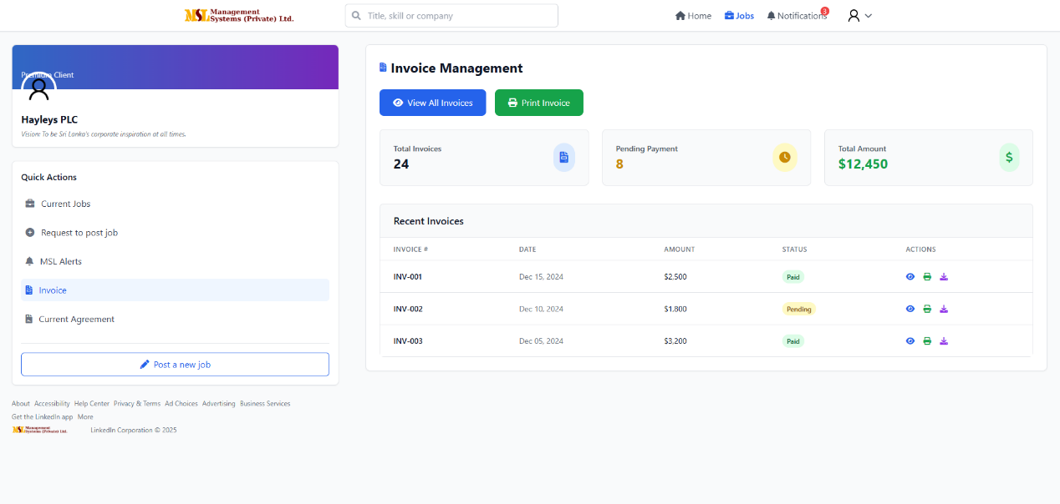
Recent Invoices Table
Field Name | Data Type | Max Length | Input Type | Description / Usage
invoice_id | INT | — | Auto-Generated | Unique invoice identifier
job_id | INT | — | System-Generated | Primary key linking invoice to specific job for access control
client_user_id | INT | — | System-Generated | Identifies which client user owns this invoice
invoice_number | VARCHAR | 50 | Text | System-generated invoice reference number
date | DATE | — | Date Picker | Date when invoice was issued
amount | DECIMAL(10,2) | — | Numeric | Total invoice value in local currency
status | VARCHAR | 30 | Dropdown | Payment status: Paid, Pending, Overdue, Cancelled
actions | VARCHAR | 50 | Buttons / Links | Available options: View Details, Download PDF, Pay Now
Access Control & Data Filtering
- Job-Based Invoice Access: Each invoice is linked to specific Job ID ensuring client users only see invoices for their own jobs
- User-Specific Billing: Invoice table displays only records associated with the client user's Job IDs
- Permission Inheritance: Follows same Job ID access control rules as other system modules
- Financial Data Isolation: Client users cannot view invoices from other users, even for same company
Invoice Management Features
- Status Tracking: Clear visibility of payment status across all invoices
- Quick Actions: Direct access to view details, download documents, or process payments
- Chronological Organization: Recent invoices displayed with date sorting
- Amount Visibility: Clear display of invoice values for financial tracking
- Job Context: Each invoice maintains connection to specific job for reference

6.6 Agreements Management
Location: Dashboard → Agreements
Agreement Types
- Master Service Agreement (MSA) - Overall client-MSLL partnership terms
- Job-Specific Agreements - Individual agreements for each job posting
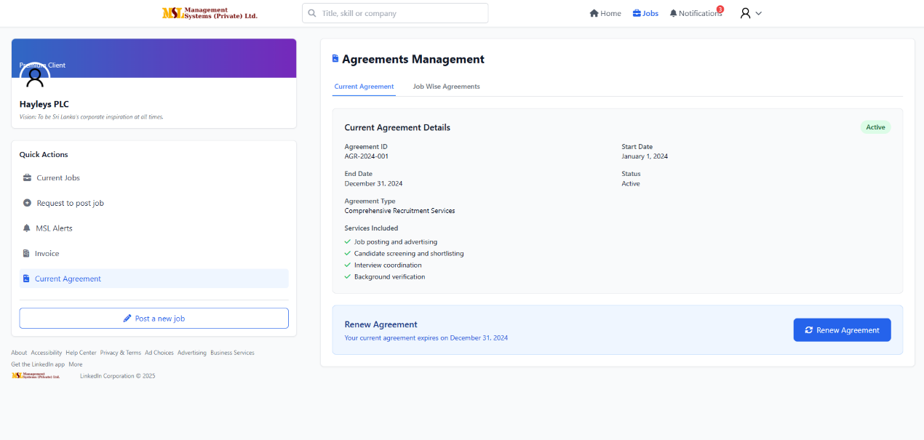
Current Agreements Page
A. Company-Wise Agreement
Field Name | Data Type | Max Length | Input Type | Description / Usage
agreement_id | INT | — | Auto-Generated | Unique identifier for company-level agreement
job_id | INT | — | System-Generated | Primary key linking agreement to specific job for access control
client_user_id | INT | — | System-Generated | Identifies which client user owns this agreement
company_name | VARCHAR | 150 | Text (View Only) | Client company name associated with the agreement
agreement_date | DATE | — | View Only | Date when agreement was initially established
expiry_date | DATE | — | View Only | Agreement termination or renewal date
status | VARCHAR | 30 | View Only | Current status: Active, Expired, Pending Renewal
renewal_request | BOOLEAN | — | Button / Action | Allows client user to request agreement renewal
Access Control & Management
Available Actions:
- View - Read agreement terms and conditions
- Download - Save agreement copy to local device
- Sign - E-signature functionality for digital execution
- Upload Signed Copy - Submit executed agreement document
Data Isolation Rules:
- Job-Based Agreement Access: Each agreement is linked to specific Job ID ensuring client users only see agreements for their own jobs
- User-Specific Agreement Management: Agreement actions and visibility limited to assigned client user
- Permission Enforcement: Follows same Job ID access control rules as other system modules
- Document Segregation: Client users cannot access agreements from other users, even within same company

Job-Wise Agreement (List + New Agreement Creation)
Field Name | Data Type | Max Length | Input Type | Description / Usage
agreement_id | INT | — | Auto-Generated | Unique identifier for each job agreement
job_id | INT | — | System-Generated | Primary key linking agreement to specific job for access control
client_user_id | INT | — | System-Generated | Identifies which client user can access this agreement
job_title | VARCHAR | 150 | Dropdown / Text | Job title linked to this specific agreement
agreement_date | DATE | — | Date Picker | Date of signing or activation of the agreement
fee | DECIMAL(10,2) | — | Numeric | Agreed service fee for the specific job post
reimbursable_expenses | DECIMAL(10,2) | — | Numeric | Expenses reimbursable to MSL by the client for this job
invoice_value | DECIMAL(10,2) | — | Numeric | Total invoice amount before taxes and charges
sscl | DECIMAL(10,2) | — | Numeric | Standard Service Charge Levy amount if applicable
vat_18_percent | DECIMAL(10,2) | — | Auto-Calculated | VAT applied at 18% of the invoice value
total | DECIMAL(10,2) | — | Auto-Calculated | Grand total after applying all taxes and charges
status | VARCHAR | 30 | Dropdown | Agreement status: Active, Completed, Expired, Pending
action | VARCHAR | 50 | Button / Action | Available actions: View, Edit, Download agreement
Access Control & Financial Management
- Job-Based Agreement Isolation: Each job-specific agreement is strictly linked to its Job ID, ensuring client users only access agreements for their assigned jobs
- User-Specific Financial Data: All financial calculations and agreement terms are scoped to individual client users
- Automated Calculations: VAT and total amounts are automatically calculated to ensure accuracy and consistency
- Status-Driven Workflow: Agreement status determines available actions and editing permissions for client users
Agreement Creation & Management
New Agreement Workflow:
- Client user selects from their assigned job titles in dropdown
- System automatically links agreement to specific Job ID and client user
- Financial terms are established per job requirements
- Automated tax calculations ensure billing accuracy
Agreement Actions:
- View: Review agreement terms and financial details
- Edit: Modify agreement details (subject to status permissions)
- Download: Save agreement documentation for records

7. MSL Admin Guide

MSL Administrators maintain the highest system privileges with comprehensive access to platform management and monitoring capabilities.

7.1 Admin Dashboard Overview
Admin Dashboard Widgets
- Total Job Seekers - Complete count of registered candidate profiles
- Active Client Accounts - Number of currently enabled client users
- Live Job Postings - Active jobs currently visible on portal
- Today's Interviews - Interviews scheduled for current date
- Pending Approvals - Job requests awaiting admin review
- System Activity Logs - Platform usage and transaction records
Dashboard Page
Field Name | Data Type | Max Length | Input Type / Source | Description / Usage
client_count | INT | — | Auto-Calculated | Total number of registered client users in system
seeker_engagement_count | INT | — | Auto-Calculated | Active job seeker interactions and application activities
current_day_jobs_count | INT | — | Auto-Calculated | New job requests submitted on current date
current_day_interviews_count | INT | — | Auto-Calculated | Interviews scheduled for the current system date
report_date | DATE | — | System-Generated | Timestamp of latest dashboard data refresh

Admin Access & Data Management
Comprehensive System Visibility
- Cross-Client Overview: Aggregate analytics across all client users and job seekers
- Job-Level Monitoring: Ability to view and manage all jobs regardless of assignment
- System-Wide Reporting: Access to complete platform metrics and performance data
- Administrative Controls: Full permissions for user management and system configuration
Job Assignment Workflow
- Automatic Job Distribution: System assigns incoming job requests to available admins
- Manual Reassignment: Super admin capability to redistribute jobs between admin users
- Workload Balancing: Dashboard displays pending assignments for optimal distribution
- Performance Tracking: Monitoring of admin response times and approval rates
Dashboard Navigation & Features
Quick Action Panel
- Pending Approvals - Direct access to job requests requiring review
- Client Management - User account creation and maintenance
- System Alerts - Platform notifications and issue resolutions
- Reporting Tools - Analytics and performance metrics export
Real-Time Monitoring
- Activity Stream - Live feed of system events and user actions
- Performance Metrics - Key indicators of platform health and usage
- Alert Management - System notifications and priority issues
- User Support - Access to help desk and client assistance tools

7.2 Seekers Management
Where: Admin → Users → Seekers
Capabilities:
- View complete seeker profile details including full CV and contact information
- Filter seekers by sector, experience level, and verification status
- Manage seeker account status (Active, Inactive, Verified, Blacklisted)
- Blacklist users with required reason documentation
- Manually add new seekers to the system when needed
Blacklist Management
- Required Documentation: You must provide specific reason for blacklisting (policy violation, fake profile, spam, etc.)
- System Impact: Blacklisted users are automatically blocked from applying to jobs
- Client Notification: Flagged profiles are visibly marked to clients during review
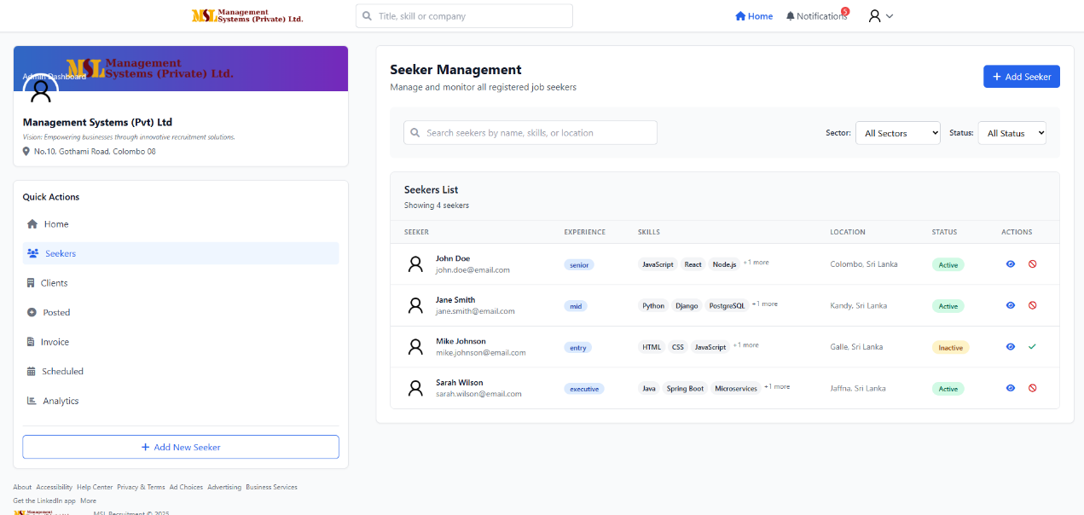
- Audit Trail: All blacklist actions are logged with admin identification
Seeker Management Page
Field Name | Data Type | Max Length | Input Type | Description / Usage
seeker_id | INT | — | Auto-Generated | Unique identifier for each job seeker
name | VARCHAR | 120 | Text | Full name of the job seeker
experience | DECIMAL(3,1) | — | Numeric | Years of professional experience
skills | VARCHAR | 255 | Text | Primary skills and competencies
location | VARCHAR | 120 | Text | City or geographical area of residence
status | VARCHAR | 30 | Dropdown | Account status: Active, Inactive, Verified, Blacklisted
actions | VARCHAR | 50 | Button / Action | Available options: View Profile, Edit Details, Status Update
search_filter | VARCHAR | 100 | Search Input | Search by name, skills, location, or keywords
add_new_seeker | BOOLEAN | — | Button | Manual addition of new seeker profiles
Advanced Filtering Options
- Sector Specialization: Clinical, Regulatory, Medical Affairs, etc.
- Experience Level: Entry, Mid, Senior, Executive
- Verification Status: Verified, Pending, Unverified
- Activity Status: Active, Inactive, Recently Applied
- Blacklist Status: Normal, Flagged, Blacklisted
Profile Management Actions
- View Full Profile: Access complete CV, application history, and documents
- Edit Details: Update seeker information and profile data
- Status Management: Change account status and verification flags
- Document Access: View and manage uploaded resumes and supporting files
- Application History: Review job applications and interaction timeline
Search & Filter Capabilities
- Quick Search: Instant filtering by name or keyword
- Advanced Filters: Multi-criteria filtering for targeted seeker selection
- Export Functionality: Download filtered seeker lists for reporting
- Bulk Actions: Apply status changes to multiple seekers simultaneously

7.3 Clients Management
Where: Admin → Clients
Admin Capabilities
- View and manage all client accounts and company profiles
- Edit client details and company information
- Suspend client accounts temporarily for violations
- Permanently deactivate client accounts when necessary
- Create new client accounts with unique login credentials
Client Status Management
- Active: Normal account status with full system access
- Suspended: Temporary restriction due to violations or non-payment
- Under Review: Account being evaluated for compliance issues
- Inactive: Permanently deactivated accounts
Suspension Guidelines
You should suspend client accounts for:
- Non-payment of invoices or service fees
- Fraudulent behavior or misrepresentation
- Repeated Terms of Service violations
- Security concerns or suspicious activities
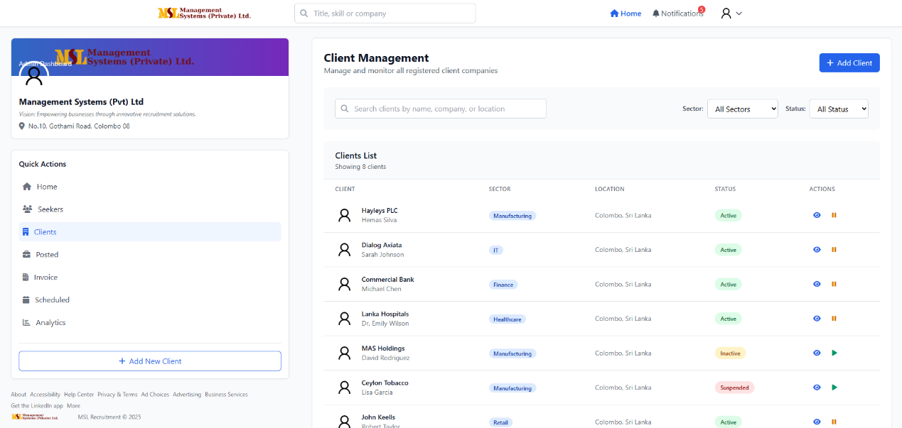

Client Management Page
Field Name | Data Type | Max Length | Input Type | Description / Usage
client_id | INT | — | Auto-Generated | Unique identifier for each registered client user
client_name | VARCHAR | 150 | Text | Official name of the client company
sector | VARCHAR | 100 | Dropdown | Business sector (Tech, Finance, Manufacturing, Healthcare)
location | VARCHAR | 120 | Text | Primary office location or headquarters
status | VARCHAR | 30 | Dropdown | System status: Active, Suspended, Under Review, Inactive
actions | VARCHAR | 50 | Button / Action | Available options: View Profile, Edit, Suspend, Remove
search_filter | VARCHAR | 100 | Search Input | Search by company name, sector, or location
add_new_client | BOOLEAN | — | Button | Manual registration of new client users
Client Account Management
Creating New Client Accounts:
- Company Registration: Enter official company details and verification
- User Account Setup: Create individual client user with unique credentials
- Access Configuration: Set initial permissions and system access levels
- Welcome Process: Generate and distribute login information to client user
Client Profile Management:
- View Complete Profile: Access company details, user accounts, and job history
- Edit Company Information: Update business details and contact information
- User Account Management: Manage individual client user accounts within company
- Billing Information: Review payment history and financial status
Advanced Client Management Features
Suspension Workflow:
- Temporary Suspension: Immediate account restriction with reason documentation
- Client Notification: Automated alert to client user about suspension status
- Compliance Review: Assessment period for violation resolution
- Reactivation Process: Restore access after compliance requirements are met
Search and Filter Capabilities:
- Quick Search: Find clients by company name or contact person
- Sector Filtering: Group clients by industry specialization
- Status Filtering: View clients by account status category
- Geographic Filtering: Sort by location for regional management
Bulk Management Actions:
- Status Updates: Apply changes to multiple client accounts simultaneously
- Export Client Lists: Download client data for reporting and analysis
- Communication Tools: Send system announcements to client groups

7.4 Current Posted Jobs
Where: Admin → Jobs → Current Posted Jobs
Admin Capabilities
- View all posted jobs across the system with comprehensive details
- Force close any job regardless of current status with mandatory reason documentation
- Transfer job ownership between client users when needed
- Export applicant data to CSV for external processing
- Edit job details and modify posting parameters
- Manage job status and publication settings

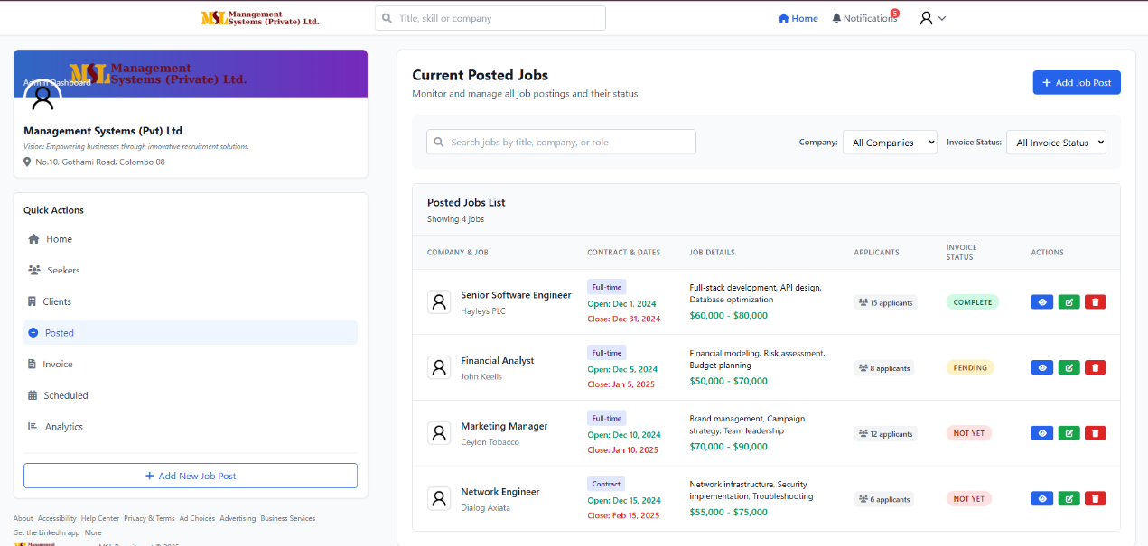
Post Jobs List Page
Field Name | Data Type | Max Length | Input Type | Description / Usage
job_id | INT | — | Auto-Generated | Unique identifier and primary key for each job post
company_name | VARCHAR | 150 | Text | Client company name associated with the job
job_title | VARCHAR | 150 | Text | Official title or designation of the job position
contract_number | VARCHAR | 50 | Text | Related contract or agreement reference number
contract_date | DATE | — | Date Picker | Date when contract or agreement was established
job_details | TEXT | — | Text Area | Summary of key responsibilities and position highlights
applicant_count | INT | — | Auto-Calculated | Total number of applicants received for this job
invoice_status | VARCHAR | 30 | Dropdown | Billing status: Pending, Paid, Generated, Not Generated
actions | VARCHAR | 50 | Button / Action | Available options: View Job, Edit, Close, Force-Publish
Job Management Columns
- Company & Job: Client company name and job title combination
- Contract & Dates: Agreement references and important timeline dates
- Job Details: Key position information and requirements summary
- Applicants: Link to view all candidates who applied to the job
- Invoice: Billing status and financial processing information
- Status: Current job posting status (Active, Closed, Pending)
- Actions: Administrative controls for job management
Administrative Job Actions
Force Close Job
- Mandatory Reason: You must provide a reason comment (250 character limit) explaining why the job is being closed
- System Enforcement: Closure cannot proceed without reason documentation
- Audit Trail: All force-close actions are logged with admin identification and reason
- Client Notification: Automated alert to client user when job is force-closed
Job Ownership Transfer
- Client Reassignment: Transfer job management to another client user within the same company
- Access Preservation: Maintains all job data while updating user permissions
- Notification Process: Both previous and new client users receive transfer notifications
Data Export Functionality
- Applicant CSV: Export complete applicant list with profile data and application details
- Custom Fields: Select specific data points for inclusion in export
- Batch Processing: Handle multiple job exports simultaneously
Additional Admin Controls
- Edit Job Details: Modify job description, requirements, and posting parameters
- Status Management: Change job status between Active, Paused, and Closed
- Force-Publish: Bypass standard approval workflow to immediately publish jobs
- Applicant Access: View and manage all applicants for each job posting

7.5 Job Invoices & Resume Access
Where: Admin → Billing → Current Job Invoices
Admin Invoice & Resume Controls
- Change invoice payment status and mark invoices as paid
- Manually grant resume access to specific client users for their assigned jobs
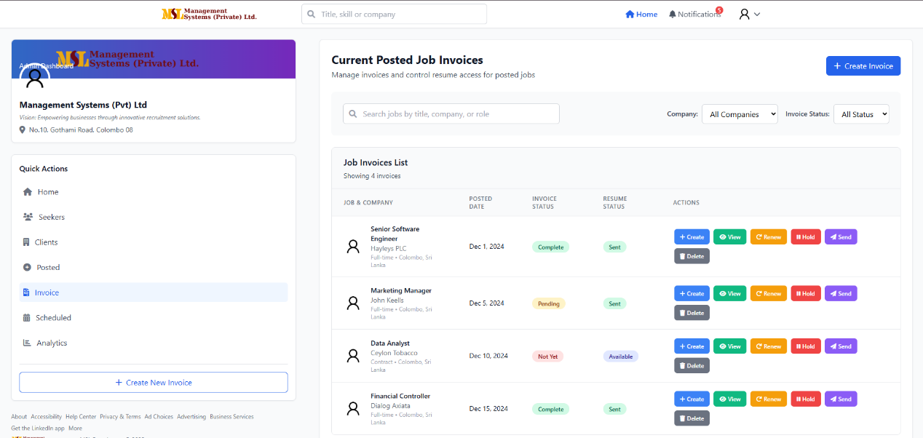
- Monitor billing status and resume review progress across all jobs

Invoice Management Page
Field Name | Data Type | Max Length | Input Type | Description / Usage
invoice_id | INT | — | Auto-Generated | Unique identifier for each invoice
job_id | INT | — | System-Generated | Primary key linking invoice to specific job for access control
job_title | VARCHAR | 150 | Text | Job title linked to the invoice
company_name | VARCHAR | 150 | Text | Client company name associated with the job
posted_date | DATE | — | Date Picker | Date when invoice was created or job was posted
invoice_status | VARCHAR | 30 | Dropdown | Current status: Pending, Paid, Overdue, Cancelled
resume_status | VARCHAR | 30 | Dropdown | Resume access status: Restricted, Available, In Review
actions | VARCHAR | 50 | Button / Action | Available options: View Invoice, Download, Update Status
Management Columns Display
- Job & Company: Job title and client company name combination
- Posted Date: Invoice creation or job posting date
- Invoice Status: Current payment and billing status
- Resume Status: Client access level to candidate resumes
- Actions: Administrative controls for invoice and resume management
Administrative Controls
Invoice Status Management
- Mark as Paid: Update invoice status to reflect payment receipt
- Status Tracking: Monitor payment progress and identify overdue invoices
- Financial Reporting: Generate billing reports based on invoice status
- Client Notification: Automated payment confirmation to client users
Resume Access Control
- Toggle Access: Switch resume availability between Restricted and Available
- Manual Granting: Specifically enable resume access for individual client users
- Status-Based Rules: Link resume access to invoice payment status when required
- Client Notification: Alert client users when resume access becomes available
Access Control Enforcement
- Job-Based Permissions: Resume access is controlled by Job ID, ensuring client users only see resumes for their assigned jobs
- User-Specific Access: Each resume access grant is specific to the individual client user
- Audit Trail: All resume access changes are logged with admin identification
- Security Compliance: Maintain strict data isolation between client users
Workflow Integration
Resume Access Triggers
- Automatic Release: Configure system to automatically grant access upon invoice payment
- Manual Override: Admin ability to grant access regardless of payment status
- Temporary Access: Set time-limited resume access for client review periods
- Bulk Management: Apply resume access changes to multiple jobs simultaneously
Reporting & Monitoring
- Access Logs: Track which client users have accessed which resumes
- Invoice Analytics: Monitor payment patterns and billing efficiency
- Compliance Reporting: Generate reports for financial and data access audits
- Performance Metrics: Track time between invoice payment and resume access activation

7.6 Interview Schedule Management
Where: Admin → Interviews
Admin Interview Management Capabilities
- View interviews across multiple timeframes: Today's Scheduled, Upcoming, Past
- Create new interviews by selecting job, candidate, interviewer, and location
- Reschedule or cancel existing interviews with automated notifications
- Manage interview reminders and booking requirements
- Track interview status and completion rates
Interview Schedule Views
Today's Scheduled Interviews
- Immediate overview of all interviews occurring on the current date
- Quick access to interview details and candidate materials
- Status monitoring for same-day interview management
Upcoming Interviews
- Forward-looking schedule for planning and resource allocation
- Advanced notification of interview workload
- Preparation time for upcoming candidate evaluations
Past Interviews
- Historical record of completed interviews
- Reference for candidate tracking and feedback review
- Performance analysis and reporting data
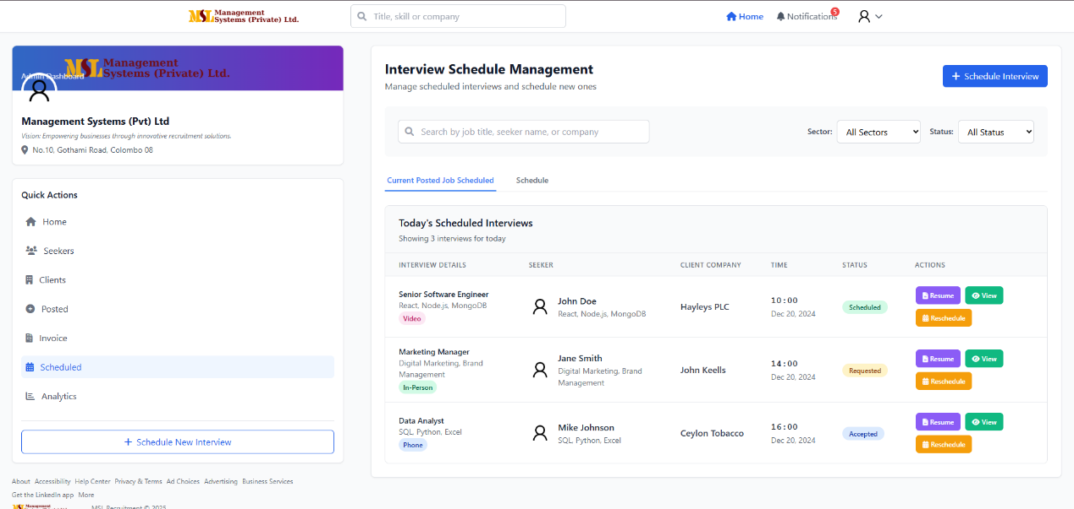
Current Posted Job Schedule Tab
Field Name | Data Type | Max Length | Input Type | Description / Usage
schedule_id | INT | — | Auto-Generated | Unique identifier for each scheduled interview
job_id | INT | — | System-Generated | Primary key linking interview to specific job for access control
job_title | VARCHAR | 150 | Text | Job post title for which the interview is scheduled
seeker_name | VARCHAR | 120 | Text | Candidate name attending the interview
client_company | VARCHAR | 150 | Text | Company name conducting the interview
time | TIME | — | Time Picker | Scheduled interview time
status | VARCHAR | 30 | Dropdown | Current status: Scheduled, Rescheduled, Completed, Cancelled
actions | VARCHAR | 50 | Button / Action | Available options: View Resume, View Details, Reschedule

Interview Creation & Management
New Interview Setup
- Job Selection: Choose from active jobs based on your admin assignments
- Candidate Assignment: Select from applicants for the specific job
- Interviewer Designation: Assign one or multiple interviewers
- Location Coordination: Set physical location or virtual meeting links
- Automated Notifications: System notifies candidates and clients upon scheduling
Interview Reminder System
Job Posting Screen Reminders:
- Closing Date Alert: Notification when job application deadline approaches
- Interview Scheduling Reminder: -2 days notice for interview coordination needs
- Boardroom Booking Alert: -2 days reminder for physical space reservations
Applicant Notifications:
- Interview Reminder: -1 day notification to candidate about scheduled interview
- Confirmation Requirements: Candidate acknowledgment and preparation details
Administrative Workflow
Scheduling Coordination
- Date Management: Set and track interview scheduling timelines
- Resource Booking: Coordinate interview locations and equipment
- Participant Management: Ensure all parties are available and prepared
- Conflict Resolution: Handle scheduling conflicts and adjustments
Status Management
- Real-time Updates: Modify interview status as events occur
- Completion Tracking: Mark interviews as completed with feedback
- Cancellation Handling: Process interview cancellations with reason documentation
- Rescheduling: Adjust interview times while maintaining all linked data
Communication Automation
- Instant Notifications: Automatic alerts for all schedule changes
- Reminder System: Timely prompts for upcoming interviews
- Document Access: Easy retrieval of candidate resumes and job details
- Feedback Collection: Streamlined post-interview evaluation process

Schedule ASAP Tab
Purpose
The Schedule ASAP Tab provides you with immediate visibility into jobs requiring urgent interview scheduling attention, allowing you to quickly address time-sensitive hiring needs.
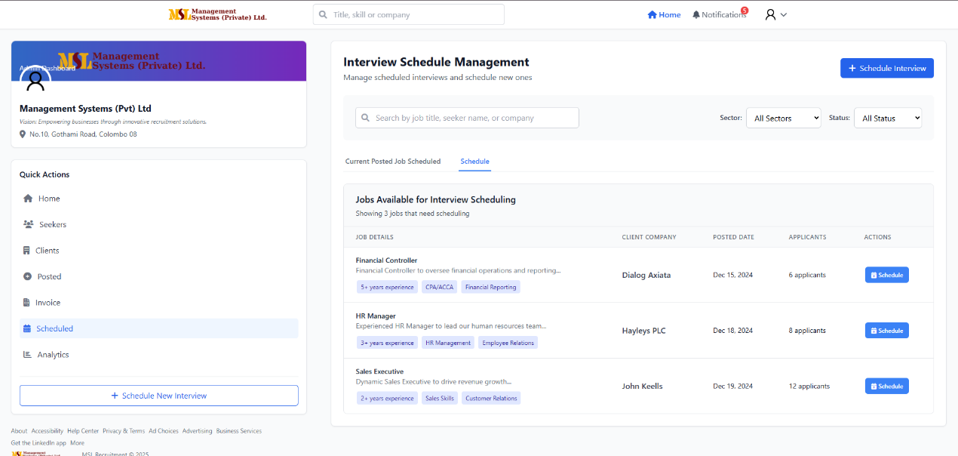
Schedule ASAP Management Table
Field Name | Data Type | Max Length | Input Type | Description / Usage
job_id | INT | — | Auto-Generated | Unique identifier and primary key for job access control
job_title | VARCHAR | 150 | Text | Job position requiring immediate interview scheduling
client_company | VARCHAR | 150 | Text | Company that posted the urgent job requirement
posted_date | DATE | — | Date Picker | Original date when the job was posted to the system
applicants_count | INT | — | Auto-Calculated | Number of qualified applicants awaiting interview scheduling
actions | VARCHAR | 50 | Button / Action | Quick options: Schedule Now, View Applicants, Close Job

ASAP Scheduling Workflow
Priority Management
- Urgent Job Identification: System automatically flags jobs needing immediate scheduling based on posting date and applicant volume
- Quick Access: Direct scheduling capability without navigating through multiple screens
- Priority Sorting: Jobs sorted by urgency level based on business rules and client requirements
Immediate Actions Available
Schedule Now
- Quick Interview Setup: Direct access to interview scheduling interface for the specific job
- Candidate Selection: Choose from pre-screened applicants for immediate scheduling
- Resource Allocation: Quickly assign interviewers and locations for urgent needs
View Applicants
- Candidate Review: Access the full list of applicants for the urgent job
- Quick Filtering: Sort applicants by qualifications and availability
- Batch Scheduling: Schedule multiple interviews efficiently for the same job

Close Job
- Rapid Closure: Immediately remove job from active posting if no longer needed
- Reason Documentation: Provide closure reason for reporting and client communication
- Applicant Notification: Automatically notify candidates of job status change
Administrative Features
ASAP Tab Benefits
- Time-Sensitive Management: Focus on jobs requiring immediate attention to prevent candidate drop-off
- Efficiency Optimization: Reduce time-to-interview for critical hiring needs
- Workload Prioritization: Visual highlighting of urgent scheduling requirements
- Client Satisfaction: Ensure prompt follow-up on high-priority job postings
Monitoring & Reporting
- Urgency Metrics: Track response times for ASAP job scheduling
- Performance Tracking: Monitor how quickly urgent jobs move through interview process
- Client Communication: Provide updates on urgent scheduling progress to client users
- System Analytics: Identify patterns in urgent hiring needs across different sectors

7.7 Logs & Audit Trail
You have comprehensive access to system audit logs that track all critical administrative actions across the platform. These logs provide complete transparency and accountability for system changes and security events.
Audit Log Management Table
Field Name | Data Type | Max Length | Input Type | Description / Usage
log_id | INT | — | Auto-Generated | Unique identifier for each audit log entry
job_id | INT | — | System-Generated | Primary key linking log entry to specific job for access control
admin_user_id | INT | — | System-Generated | Identifies which admin performed the action
action_type | VARCHAR | 50 | Dropdown | Category of action: Blacklist, Invoice, Job, Resume, System
action_description | TEXT | — | Text Area | Detailed description of the performed action
timestamp | DATETIME | — | Auto-Generated | Exact date and time when action occurred
ip_address | VARCHAR | 45 | System-Captured | IP address from which action was performed
affected_user_id | INT | — | System-Generated | User who was impacted by the action (if applicable)
previous_value | TEXT | — | Text Area | State or value before action was taken
new_value | TEXT | — | Text Area | State or value after action was completed
severity_level | VARCHAR | 20 | Dropdown | Impact level: Low, Medium, High, Critical
Auditable Action Categories
User Management Actions
- Blacklisting Events: All job seeker blacklisting actions with reasons
- Client Suspensions: Temporary or permanent client account suspensions
- User Status Changes: Modifications to user verification or access status
- Profile Modifications: Administrative edits to user profiles
Financial & Billing Actions
- Invoice Status Changes: Updates to payment status (Pending → Paid, etc.)
- Fee Modifications: Changes to service fees or billing amounts
- Payment Overrides: Manual payment processing or adjustments
- Billing Rule Changes: Modifications to invoicing rules or templates
Job Management Actions
- Force Publishing: Jobs published bypassing standard approval workflow
- Job Closures: Administrative job closures with reason documentation
- Ownership Transfers: Job reassignment between client users
- Status Modifications: Changes to job posting status or visibility
Data Access Actions
- Resume Access Toggles: Changes to client resume viewing permissions
- Document Access Grants: Manual override of document access restrictions
- Export Activities: Data export actions and file downloads
- Report Generation: System report creation and access
Audit Trail Features
Comprehensive Tracking
- Real-time Logging: Immediate capture of all administrative actions
- Detailed Context: Complete before-and-after state documentation
- User Identification: Clear attribution of actions to specific admin users
- Job-Based Filtering: Ability to view logs filtered by specific Job ID
Search & Filter Capabilities
- Date Range Filtering: View logs for specific time periods
- Action Type Filtering: Isolate specific categories of administrative actions
- User-Based Filtering: Review actions performed by specific admin users
- Job-Based Filtering: See all audit events related to specific jobs
- Severity Level Filtering: Focus on high-priority security events
Security & Compliance
- Immutable Records: Audit logs cannot be modified or deleted
- Access Control: Only users with admin privileges can view audit trails
- Data Retention: Logs are maintained according to data retention policies
- Compliance Reporting: Generate reports for regulatory requirements
Administrative Monitoring
Usage Patterns
- Admin Activity Review: Monitor administrative action frequency and types
- System Change Tracking: Document all modifications to system configuration
- Security Event Monitoring: Identify suspicious or unauthorized activities
- Performance Analysis: Track system usage and administrative workload
Reporting & Analytics
- Regular Audit Reviews: Scheduled analysis of administrative actions
- Exception Reporting: Automated alerts for unusual or high-risk activities
- Compliance Documentation: Generate evidence for internal and external audits
- Trend Analysis: Identify patterns in system usage and administrative behavior

8. Accessibility, Security & Data Privacy Notes
Accessibility: Ensure semantic HTML, alt text for images, keyboard-focusable interactive elements, and color contrast >= 4.5:1.
Security:
- Use HTTPS across the site.
- Enforce strong passwords and optional 2FA.
- Admin actions should require confirmation modals.
Data retention: Documents and applications stored per policy; previous document versions kept for 30 days by default.
Privacy: Users can request data export or account deletion via Settings → Privacy → Delete Account.

9. Non-Functional Requirements (NFRs)

- Purpose: To define the quality and constraints of the system, not just its functions.
- Content:
  - Performance:
    - Page load time < 3 seconds for most actions.
    - The system should support up to X concurrent users.
    - Search results should load within 2 seconds.
  - Availability & Reliability:
    - System uptime of 99.9% during business hours.
    - Scheduled maintenance windows (e.g., Sundays 2 AM - 4 AM).
  - Scalability:
    - The architecture should allow for horizontal scaling of the web server to handle future load increases.
  - Maintainability:
    - Code shall be well-documented.
    - The system should be modular to allow for easy updates.
  - Usability:
    - The UI shall be intuitive enough for a non-technical user to complete core tasks (registration, job posting) with minimal training.
    - The system shall comply with WCAG 2.1 AA standards.

10. Technical Overview (HTML / CSS / JS only)
Stack:
- Frontend: Static HTML pages enhanced with modular CSS (BEM/Tailwind-like) and Vanilla JS (ES6+).
- No backend frameworks included in this manual — integrations are placeholders for REST API endpoints.
Architecture & patterns:
- Single page pattern per role: each role has a main HTML file with modular JS components.
- Components: job-card, profile-editor, upload-widget, modal-dialog, table-list.
- State management: lightweight in-memory JS objects + localStorage for temporary drafts (e.g., unsaved profile edits).
- Forms & validation: client-side validation using HTML5 constraints and JS fallback.
Performance tips:
- Lazy-load images and job list pages.
- Debounce search (300 ms) to reduce filtering cost.
UI parity to LinkedIn:
- Use a 3-column layout for desktop (left nav, center feed, right suggestions).
- Keep interactions lightweight and predictable.

11. Executive Summary & Project Vision

Release Notes & Versioning
Maintain changelog entries with the following format: DD/MM/YYYY | vX.Y | Summary.
Example:
- 19/09/2015 | v1.0 | Initial release: Seeker, Client, Admin core flows.

12. Data Dictionary / Entity Relationships
- Purpose: To provide a single source of truth for all data fields, reducing ambiguity for developers and DBAs.
- Content:
  - Entity-Relationship Diagram (ERD): A visual diagram showing the main tables (Users, Seekers, Clients, Jobs, Applications, Invoices, Documents) and their relationships.
  - Detailed Table Schemas: Expand on the field lists you already have. For example, for the seekers table, list all fields from all forms (Personal Info, Current Position, etc.) in one consolidated table with:
    - Field Name, Data Type, Constraints (PK, FK, NOT NULL, UNIQUE), Default Value, and a Description.

13. API Specification (Placeholder)
- Purpose: To define how the front-end communicates with the back-end and how external systems might integrate.
- Content:
  - Architecture Style: RESTful API.
  - Authentication: Token-based (e.g., JWT).
  - Sample Endpoints:
    - POST /api/auth/login (Request: {email, password}, Response: {user, token})
    - GET /api/jobs (Query Params: ?location=Colombo&sector=Clinical)
    - POST /api/applications (Request: {job_id, seeker_id, cover_message})
    - PUT /api/admin/seekers/{id}/blacklist (Request: {reason})

14. Comprehensive Use Cases / User Stories
- Purpose: To describe system behavior from a user's perspective in a structured format.
- Content: For each major function, write a short use case.
  - Use Case: Seeker Applies for a Job
  - Actor: Job Seeker
  - Preconditions: Seeker is logged in, has a profile and at least one resume uploaded.
  - Main Flow:
    - Seeker searches and finds a job.
    - Seeker clicks "View Details."
    - System shows job details and an "Apply" button.
    - Seeker clicks "Apply."
    - System opens a modal to confirm CV and add an optional message.
    - Seeker clicks "Submit Application."
    - System confirms application, adds job to "Applied Jobs," and notifies the client.
  - Postconditions: The application is recorded in the database.

15. Wireframes or Mockups Reference
- Purpose: To link the functional requirements directly to the UI design.
- Content:
  - A dedicated section listing all key screens (e.g., "Seeker Dashboard," "Client Job Posting Form," "Admin User Management Table").
  - For each screen, include:
    - Screen Name & ID
    - Purpose
    - Reference Link/Image File Name (e.g., seeker-dashboard-v1.png)
    - Key Elements & Interactions: A bulleted list of what's on the screen and what it does.

SEEKER
- Common MSL Web Page for direction to MSL R
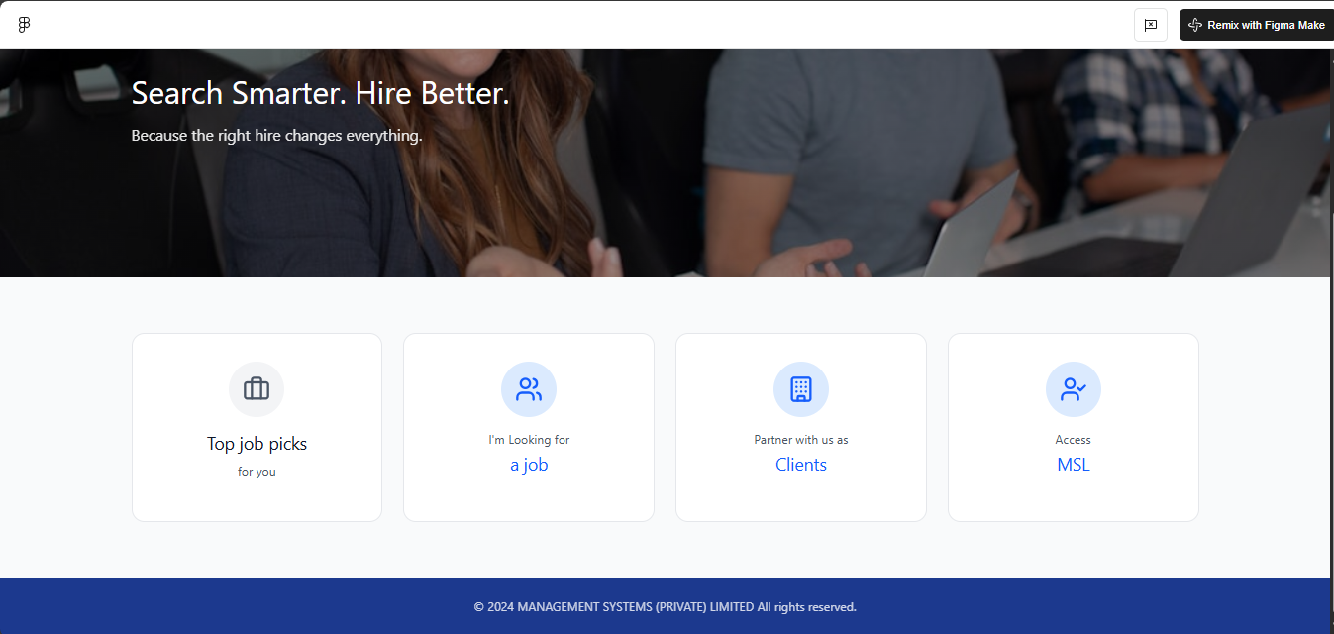
Figure 1- Return MSL R

- Seeker Login
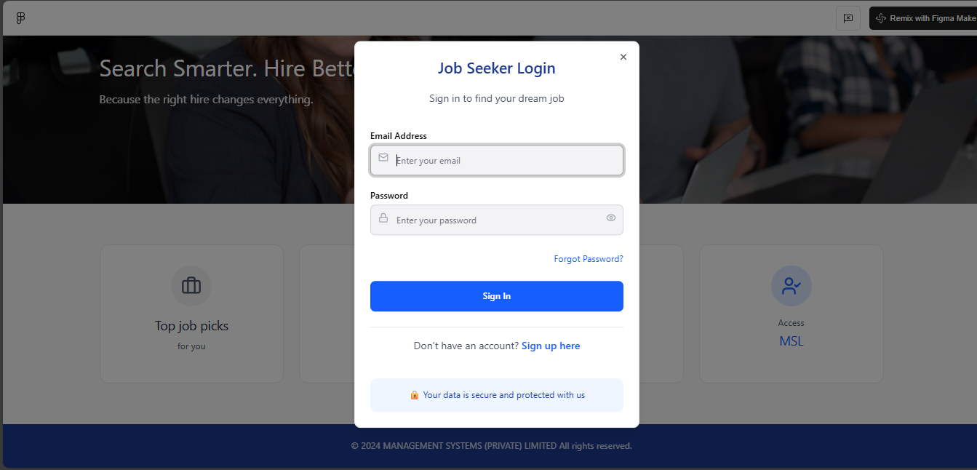
Figure 2- Seeker Login

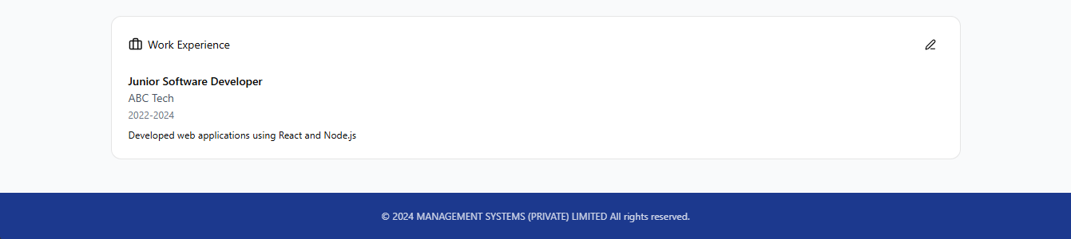
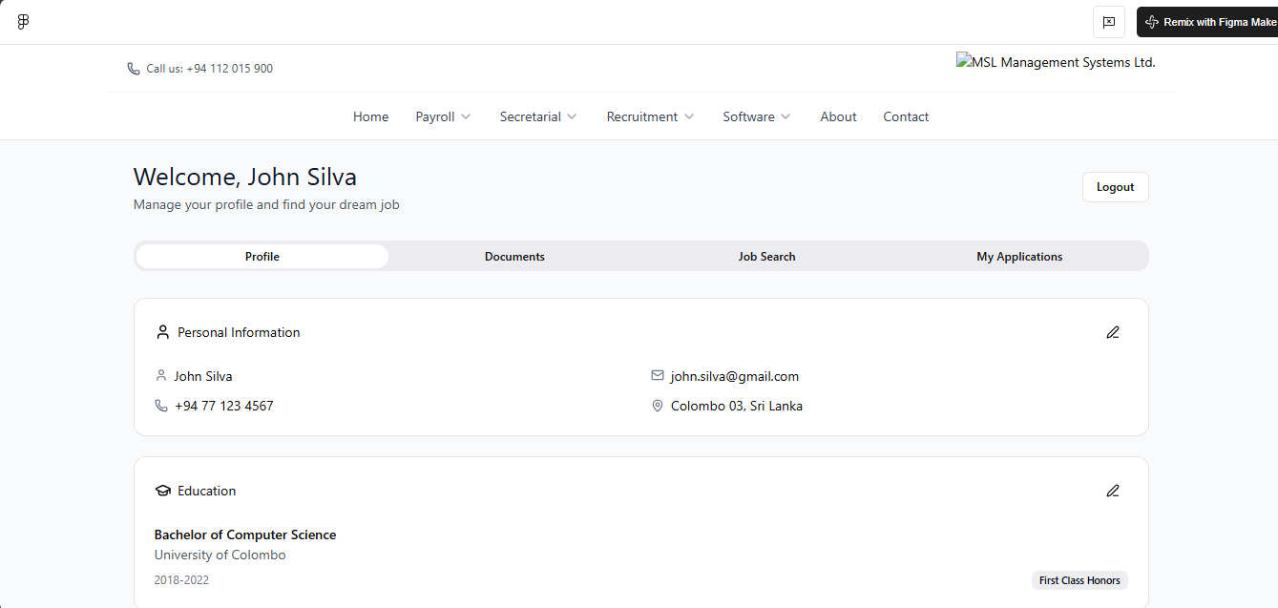
- Seeker Dashboard
Figure 3- Seeker Dashboard

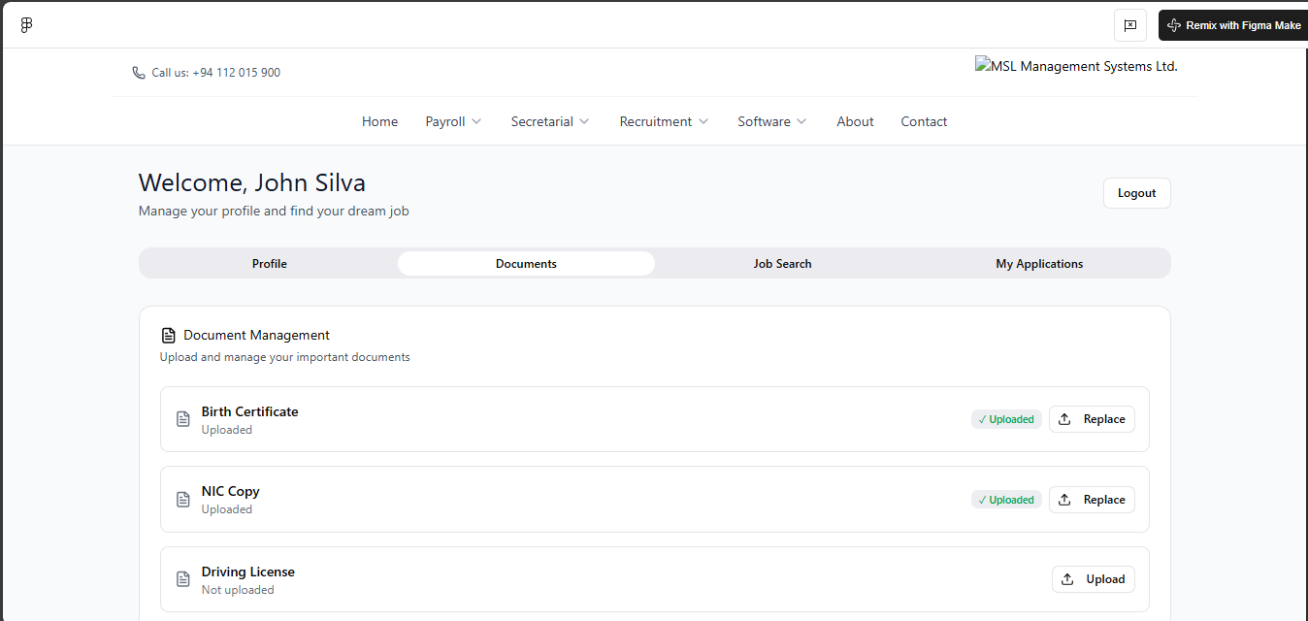
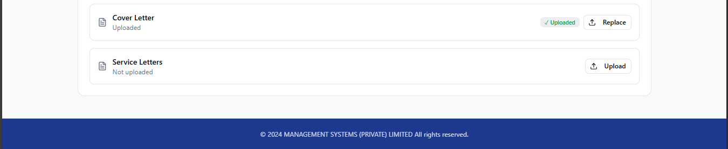
- Seeker Documentation
Figure 4- Seeker Documentation

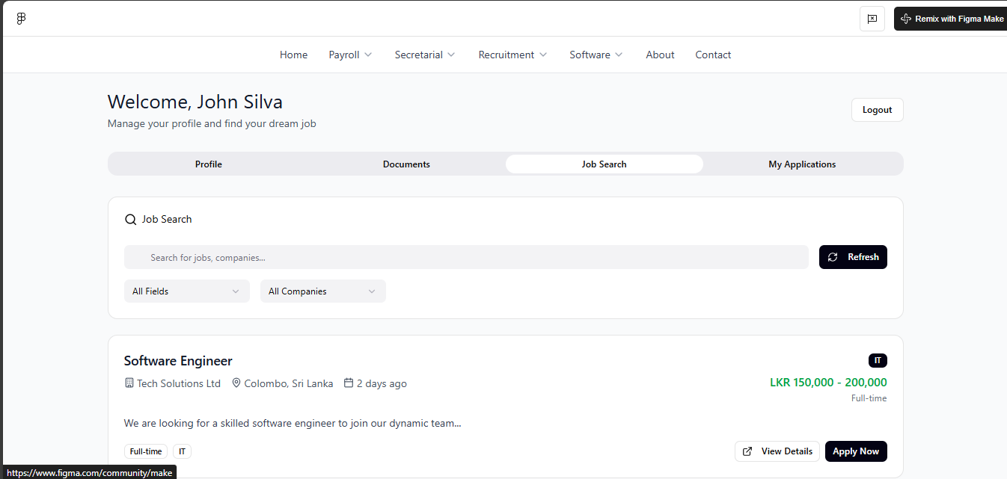
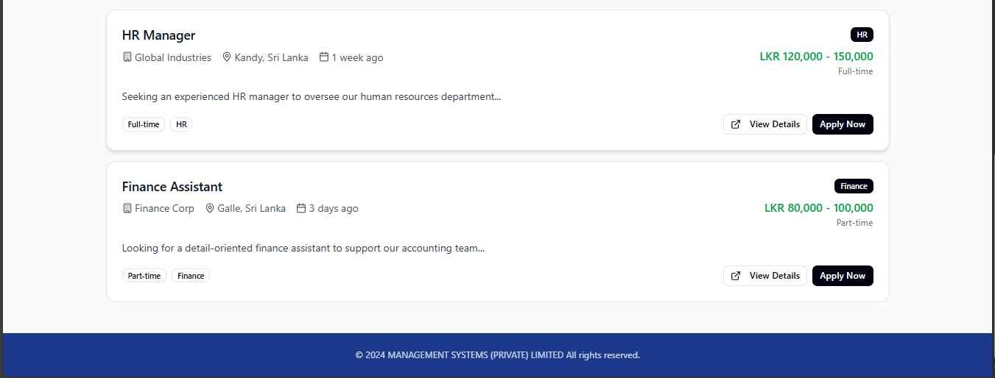
- Job Seeker Job search
Figure 5- Seeker Job search

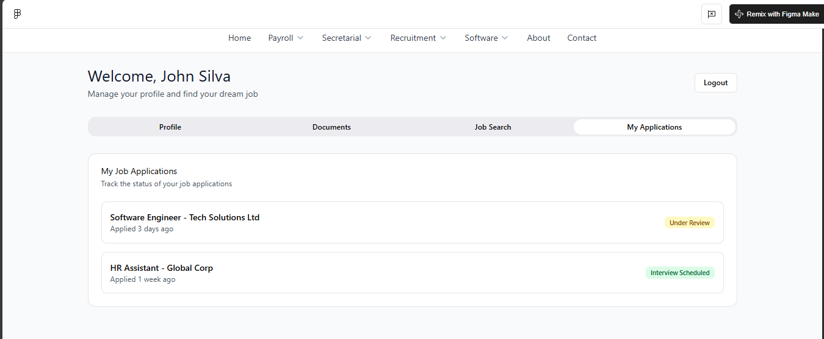
- Job Seeker My application Review
Figure 6- Seeker My Application

CLIENT
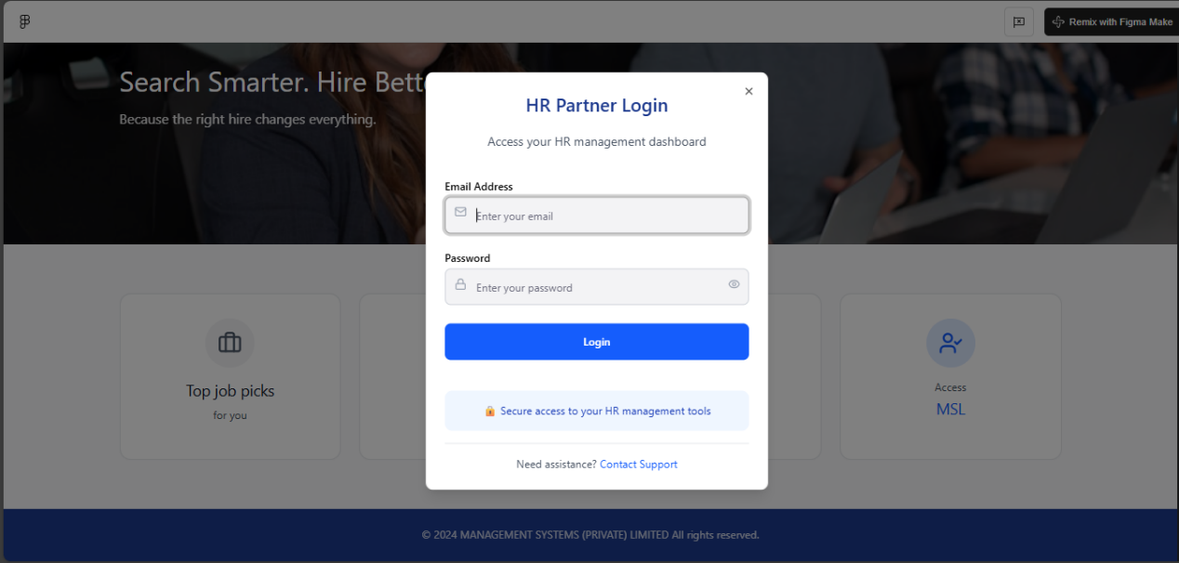
- Client Login
Figure 7- Client Login

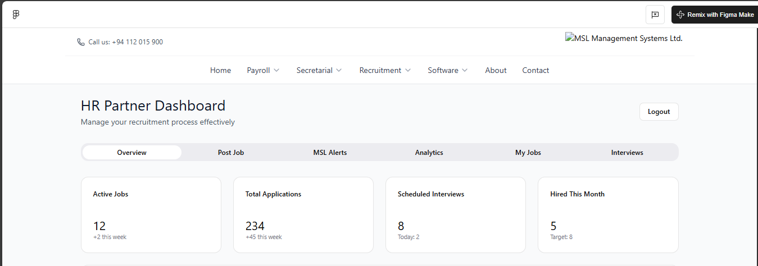
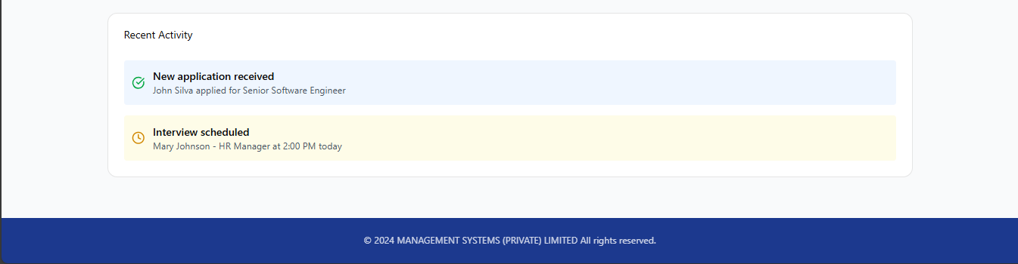
- Client Dashboard
Figure 8- Client Dashboard

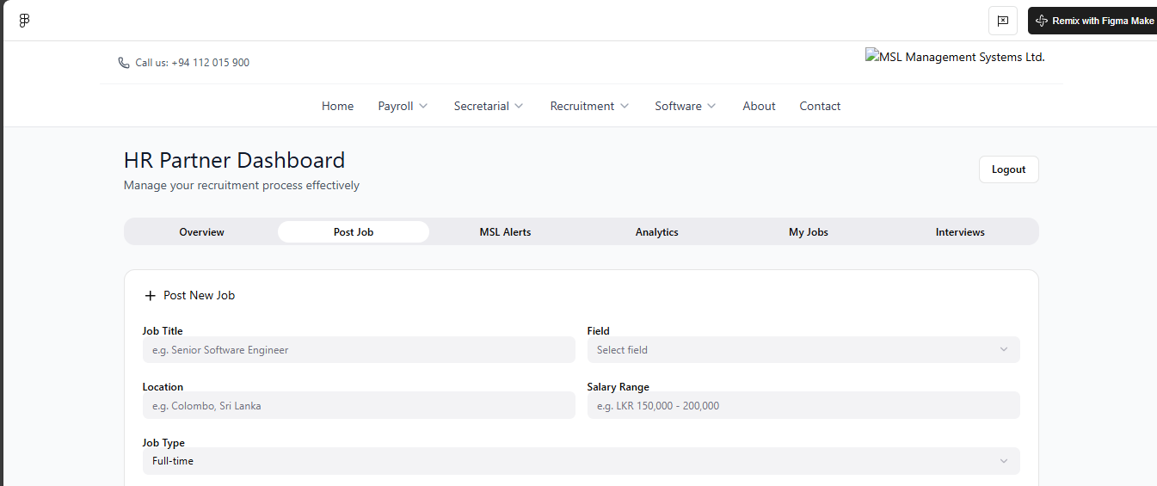
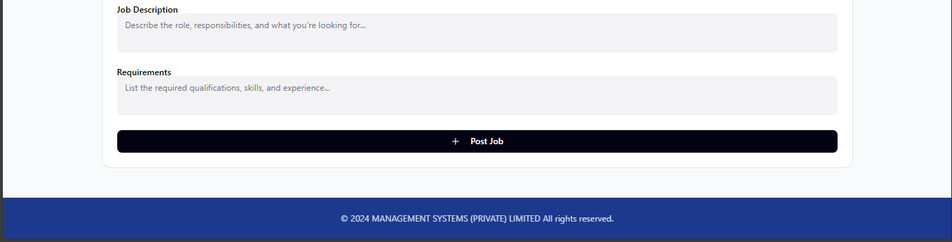
- Client Post A new JOB
Figure 9- Client Post Job

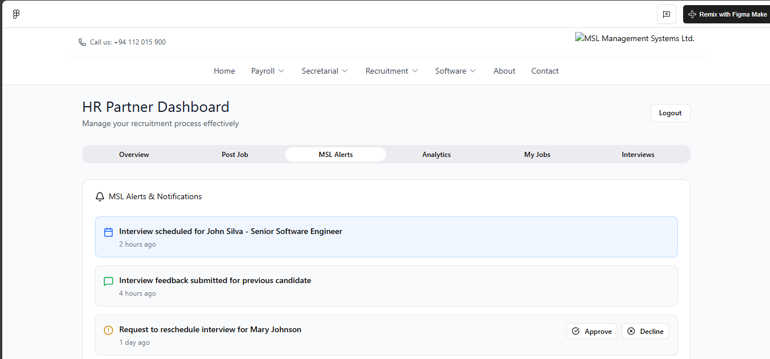

- Client MSL Alerts
Figure 10- Client MSL Alerts

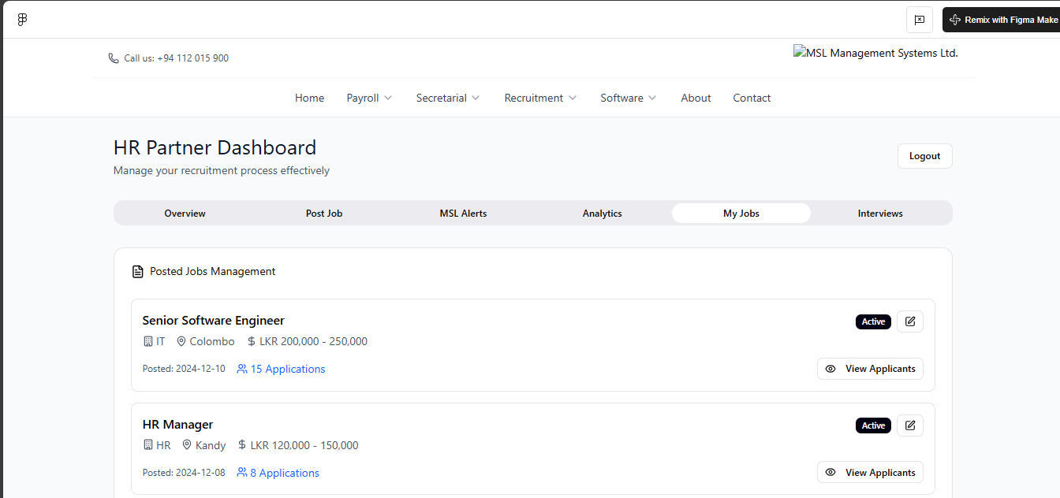

- Client Posted Jobs Management
Figure 11- Client current posted jobs

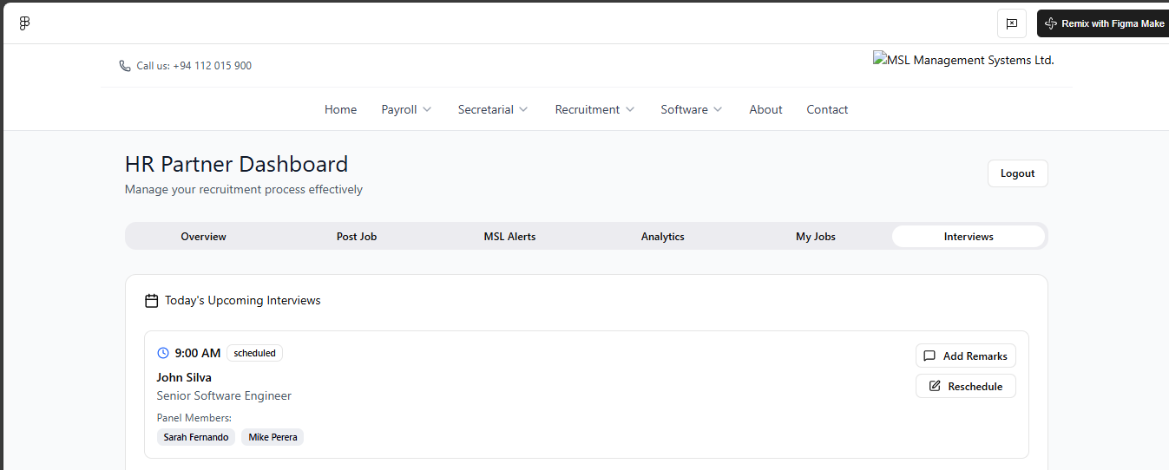
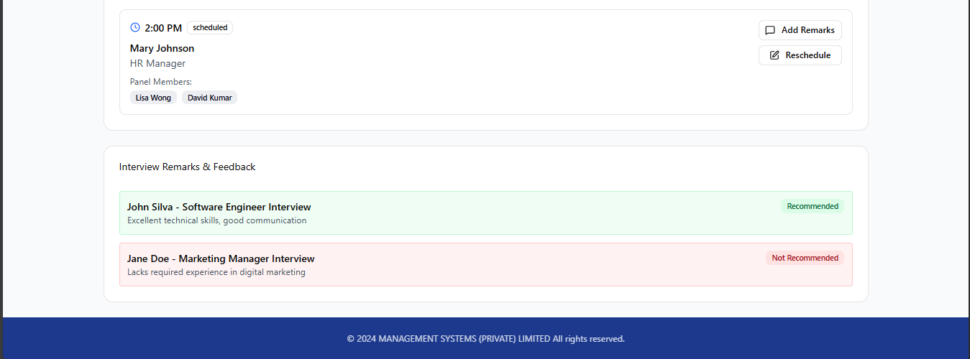
- Client Schedule Interviews
Figure 12- Client Schedule interviews

ADMIN

- Admin Login
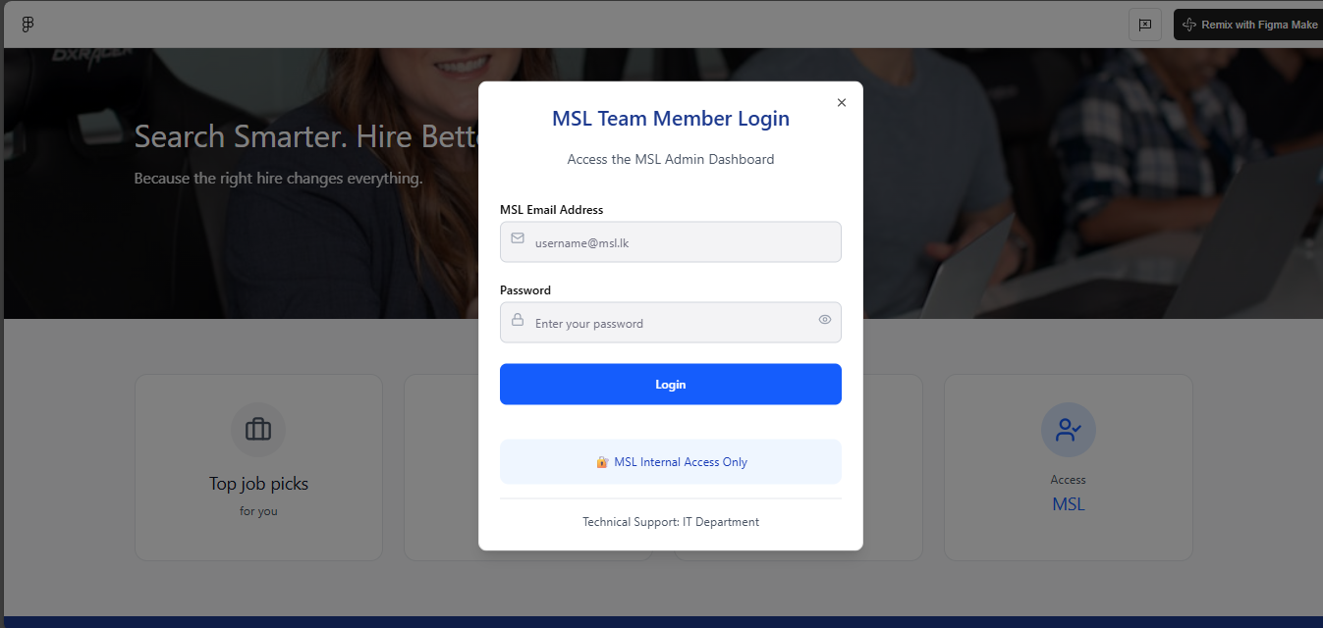
Figure 13- MSL Admin Login


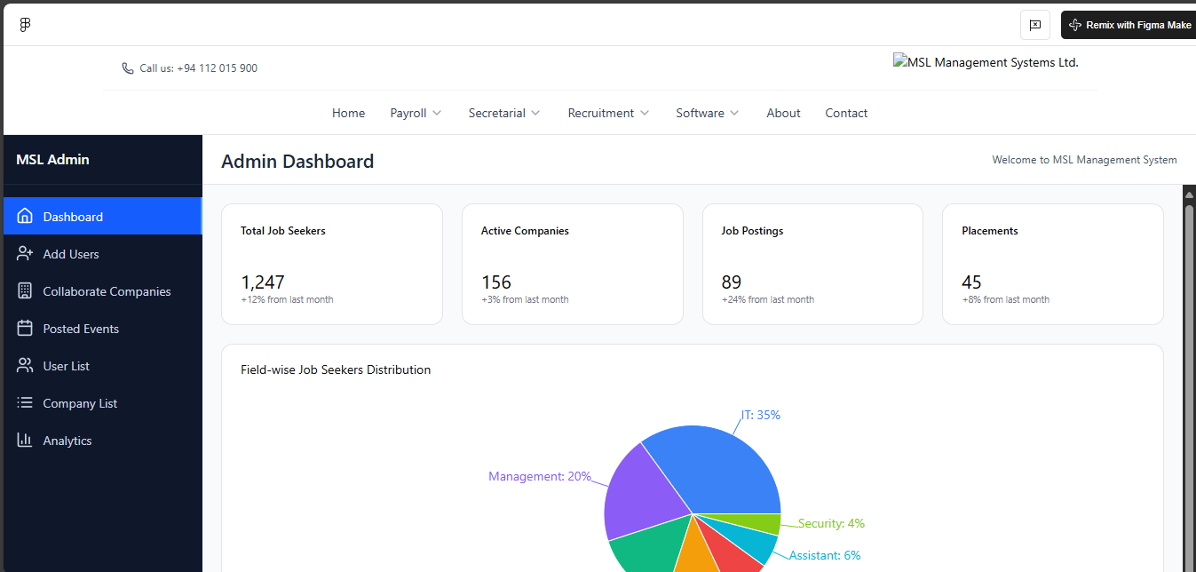
- Admin Dashboard
Figure 14- MSL Admin Dashboard

- MSL Admin Add User
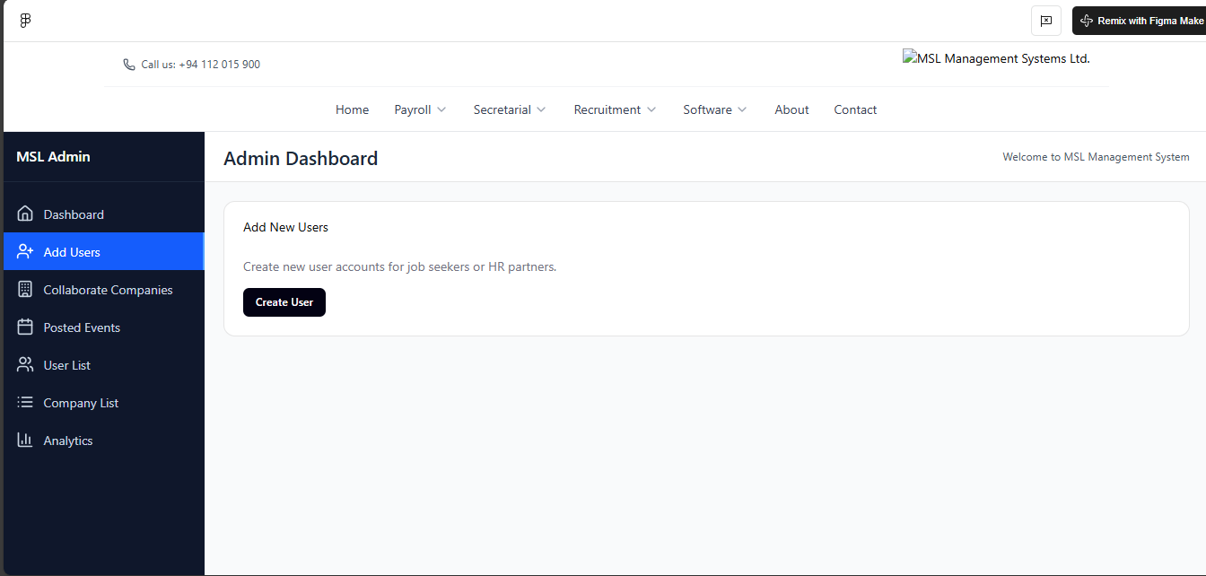

Figure 15- Admin Add User
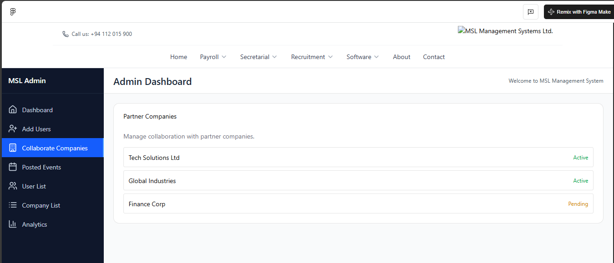

- MSL Admin Client List
Figure 16- Admin Client List

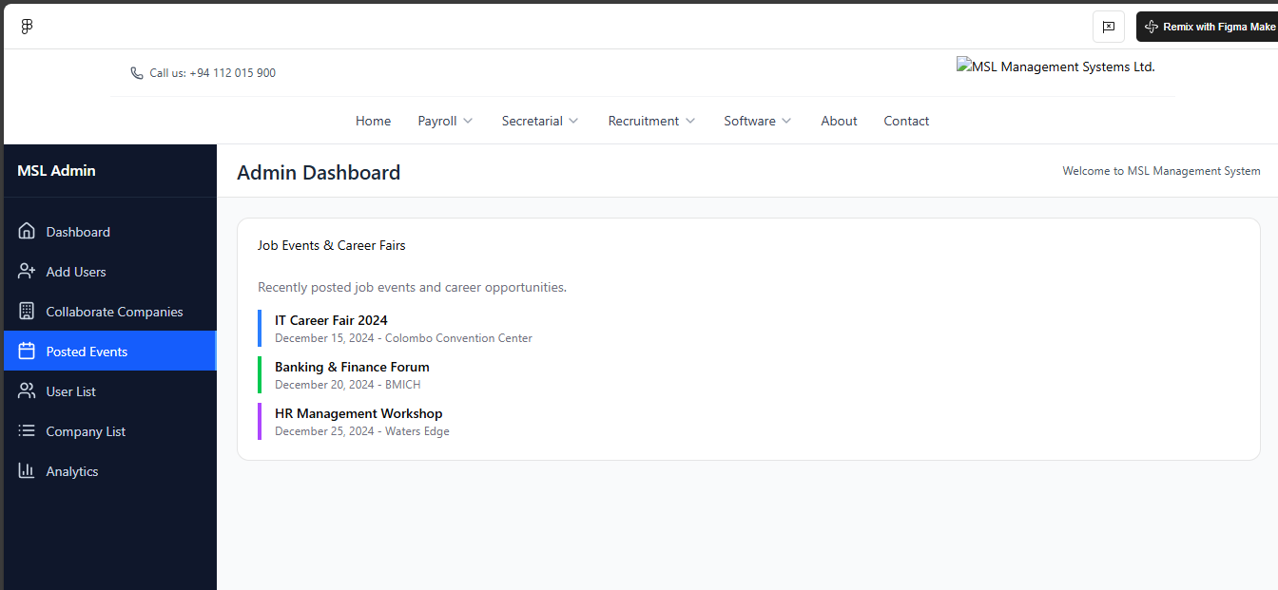

- MSL Admin Posted Events
Figure 17- Admin posted event

16. Gantt Chart

A Gantt Chart is a visual project management tool that displays tasks or activities along a timeline, showing their start and end dates, duration, and dependencies. It helps track progress, identify overlapping tasks, and ensure the project stays on schedule by providing a clear overview of the entire workflow in a single view.

17. Deployment & Infrastructure Guide
- Purpose: To specify how the system is built, deployed, and managed.
- Content:
  - Server Specifications: OS Version, IIS Version.
  - Database Setup: Oracle version, connection string details, initial schema setup scripts.
  - Build Process: Steps to compile and package the application (e.g., npm run build).
  - Deployment Process: Steps to deploy the packaged code to the IIS server.
  - Environment Variables: List of configurable settings (e.g., SMTP credentials, API keys, database connection strings).

18. Test Strategy & Plan
- Purpose: To outline the approach for verifying the system works as intended.
- Content:
  - Test Types: Unit Testing, Integration Testing, System Testing, User Acceptance Testing (UAT).
  - UAT Scenarios: A list of key test scenarios for each user role to execute before go-live. E.g., "Successfully register as a new Job Seeker," "Post a new job as a client and receive an application," "Blacklist a seeker as an Admin."
  - Performance Testing Plan: How and what will be tested for performance (e.g., load testing with 100 simultaneous users).

19. Appendix
Sample notification copy
- Application Received: "Thanks, {candidateName}. Your application for {jobTitle} has been received. Status: Submitted."
- Interview Scheduled (Client): "Interview scheduled with {candidateName} for {jobTitle} on {date} at {time}."

Field definitions
- Resume Access: whether a client can view full candidate resumes (controlled by invoice status and admin toggles).
- Invoice Status: Pending, Paid, Overdue.
Error codes (common)
- ERR_UPLOAD_SIZE — file exceeds 5 MB
- ERR_AUTH — auth failure
- ERR_FORBIDDEN — access denied

Enhanced Troubleshooting & Support Guide
(Expand Section 6 and the Appendix)
- Purpose: To provide a resource for system administrators and support staff.
- Content:
  - Common Issues & Resolutions: A table with Problem, Cause, and Solution.
  - FAQ: For each user type.
  - Support Contact Information: Who to contact for different types of issues (technical, billing, user support).

Document created: MSL Recruitment Portal — User Manual.

